

**Project Title Online Cake Shop Website**

A Project Submitted to

**University of Mumbai**

for partial completion of the Degree of

**Bachelor of Computer Science**

Under the Faculty of Science

Submitted By

**Mr. Darshan Manohar Shinde**

Under the Guidance of

**Prof. Vaishali Pawar**

**Academic Year**

**2025-26**



Pune Vidyarthi Griha’s

College Of Science And Technology. CTS No-218 , BR, Nath Pai Nagar, Ghatkopar(E),Mumbai-400 077.

# CERTIFICATE

This is to certify that the Project entitled, **“ONLINE CAKE SHOP WEBSITE”** is Bonafied work of **Mr. Darshan Manohar Shinde** bearing **Seat.no 23-415** submitted in partial fulfilment of the requirements for the award of degree of **BACHELOR OF SCIENCE IN COMPUTER SCIENCE from** University of Mumbai.

**Head of Department Internal Examiner External Examiner**

**Date of Submission**:

**College Seal**

# DECLARATION

I, the undersigned, Miss/Mrs. **Darshan Manohar Shinde**, hereby declare that the work presented in this project titled: **“ONLINE CAKE SHOP WEBSITE”** is my own original research conducted under the guidance of **Prof. Vaishali Pawar.**

It has not been submitted previously for any degree/diploma at this or any other university.

Wherever references have been made to previous works of others, they have been made to previous works of others, they have been duly cited, and included in the bibliography.

Furthermore, I declare that all information in this document has been obtained and presented in accordance with academic integrity and ethical research standards.

**Name of Candidate:**

**Signature of Candidate:**

# ACKNOWLEDGEMENT

It is difficult to list all those who have contributed to this project, as the support received has been invaluable and extensive. However, I would like to express my sincere gratitude to the **University of Mumbai**, for providing the opportunity to undertake this project.

I would like to thank our **Principal Dr. Triveni Kaul,** for facilitating the necessary resources and our **Prof. Suvarna Phulare** for moral support and guidance throughout this endeavor.

This project would not have been possible without the valuable guidance and support of my project Guide. My sincere thanks to my project Guide **Prof.**

**Vaishali Pawar**

I would also like to thank **The College Library**, for providing reference materials essential to this research.

And lastly, this project would not have been possible without **My Parents, Peers, and Everyone** who directly or indirectly assisted me in completing this project successfully.

Thank you all for your unwavering support and encouragement.

# Table of Contents

1. INTRODUCTION 4
   1. Project Objective 4
   2. Project Scope 5
2. SYSTEM DESIGN 6
   1. Existing System 6
   2. Proposed System 6
   3. Advantages of Proposed System 6
3. SYSTEM REQUIREMENTS 7
   1. Hardware Requirements 7
   2. Software Requirements 7
4. MODULES DESCRIPTION 8
   1. Admin Module 8
   2. User Module 8
5. DATA FLOW DIAGRAM 9
   1. Class Diagram 10
   2. Use Case Diagram 11
   3. Sequence Diagram 12
   4. Activity Based Diagram (user side) 13
   5. Activity Diagram (admin side) 14
   6. State Diagram (user side) 15
   7. State Diagram (admin side) 16
   8. Package Diagram 17
   9. Component Diagram 18
   10. ER Diagram 19
6. TESTING 20
   1. Functional Testing 20
   2. Usability Testing 20
7. Test Cases 21
   1. User Registration and Login 22
   2. Customization and Ordering 23
   3. Project Browsing and Search 24
   4. Checkout and Payment 25
8. SYSTEM IMPLEMENTATION 26
   1. Source Code 27
9. SCREENSHOTS 28
10. CONCLUSION 29
    1. Achievements of Project 29
    2. Future Enhancement 29
11. BIBILIOGRAPHY 30
12. PLAGARISM REPORT 31

**ABSTRACT**

This project presents the development of a dynamic, robust, and user-friendly Cake Shop Website designed to streamline the traditional process of browsing, ordering, and customizing cakes online. The core objective is to leverage modern web technologies to create a seamless e-commerce platform.

The primary goal of this system is to provide a convenient platform for customers to explore and order a wide variety of baked goods, including distinct categories such as birthday cakes, wedding cakes, cupcakes, and seasonal specialties. The website includes key functional features such as an extensive product catalog with high-quality images and descriptions, a real-time ordering system, intuitive custom cake design options, and comprehensive user account management.

The platform ensures a responsive design for optimal viewing across desktops, tablets, and smartphones. The dedicated Admin Module (built into Django's admin interface or custom) allows the cake shop owner to manage inventory, track and fulfill orders, and update product listings efficiently.

By bridging the gap between traditional cake ordering methods and modern e-commerce solutions, the Cake Shop Website offers a scalable, secure, and efficient solution that will significantly enhance customer engagement, improve business reach, and simplify overall bakery operations.

**1. INTRODUCTION**

This final year project focuses on the design and delivery of the CakeZone E-commerce Website, a dynamic online platform intended to revolutionize how the business interacts with its customers. The core motivation is to move beyond the limitations of manual or phone-based ordering, providing a highly accessible, 24/7 digital storefront for the bakery. This transition significantly enhances the operational efficiency of CakeZone while drastically improving customer convenience.

The entire system is engineered on a robust, three-tier architecture. We utilized the **Python Django framework** for the backend logic and database management, chosen for its speed, security, and "batteries-included" approach. The frontend is built using standard web technologies—**HTML5, CSS3, and JavaScript**—ensuring a fully responsive design that guarantees an optimal user experience across all devices.

The application’s key capabilities are split into two essential modules:

1. **User Module:** This consumer-facing side allows customers to easily navigate the extensive product catalog, utilize advanced **cake customization tools** (specifying flavor, size, and inscriptions), manage their secure shopping cart, and finalize orders via a **secure payment gateway**.
2. **Admin Module:** A dedicated interface allows **CakeZone** staff to manage and update product inventory, add or modify listings, and efficiently track and transition the status of every customer order from submission to fulfillment.

By providing a scalable and secure digital solution, the **CakeZone Website** bridges the gap between traditional baking artistry and modern e-commerce, delivering a comprehensive, end-to-end system that benefits both the consumer and the shop administrator.

**1.1 PROJECT OBJECTIVE**

The primary objective of this project is to successfully design, develop, and deploy a secure and fully functional e-commerce web application for CakeZone, leveraging the Python Django framework.

**Key Specific Objectives (KSOs) are defined as follows:**

1. **To Develop a Seamless User Experience:**
   * To implement a responsive and intuitive user interface (UI) using HTML, CSS, and JavaScript that enables users to browse the **CakeZone** product catalog easily on any device (desktop, tablet, mobile).
   * To provide secure and efficient **User Authentication** (registration and login) and **Profile Management** functionality.
2. **To Implement Robust E-commerce Functionality:**
   * To build an interactive **Cake Customization** module that accurately captures user specifications (e.g., flavor, weight, shape, message) and dynamically reflects pricing.
   * To integrate a reliable **Payment Gateway** (e.g., Stripe, PayPal) to facilitate secure and various modes of online payment transactions.
   * To develop a mechanism for users to **Track their Orders** in real-time and maintain a history of all past purchases.
3. **To Streamline Administrative Operations:**
   * To construct a secure **Admin Module** using Django's capabilities for authorized **CakeZone** personnel to manage products (add, edit, delete), update inventory levels, and process orders (change status from "Pending" to "Delivered").
   * To enable the generation of **Basic Sales and Order Reports** to aid management in data-driven decision-making regarding popular items and stock requirements.
4. **To Ensure System Quality and Security:**
   * To implement appropriate security measures (e.g., input validation, secure session management) to protect customer data and payment information.
   * To conduct thorough **Functional and Usability Testing** to ensure the system is bug-free, performs efficiently, and meets all defined user requirements.

**1.2 PROJECT SCOPE**

The scope of the CakeZone E-commerce Project is defined by the functionalities delivered within the two primary interfaces: the Customer Frontend and the Administrative Backend. This outlines what the system achieves and what specific areas were excluded from this iteration of development.

The Online Cake Shop Website is designed to provide a digital platform where customers can conveniently order cakes and bakery products online. The scope of this project includes:

* **Core Shopping Experience:** Secure user registration/login, browsing the entire CakeZone catalog, advanced filtering, the ability to search by keyword, and viewing detailed product descriptions.
* **Ordering Workflow:** Comprehensive cake customization options, real-time cart modification and secure multi-step checkout
* **Account Management:** Viewing order history and updating personal user profiles.
* **Management Tools:** A protected admin portal for managing the full inventory lifecycle (adding, editing, deleting cakes and variations).

**2. SYSTEM DESIGN**

This section details the architectural approach taken to construct the CakeZone website, contrasting it with traditional methods and highlighting the benefits of the modern system.

* 1. **Existing System:**

In the existing system, customers usually purchase cakes directly by visiting the shop physically. Orders are managed manually, which makes record keeping time consuming and error prone. Payment is mostly done in cash.

* 1. **Proposed System:**

The proposed system provides a user friendly online platform where customers can browse cakes, view details, and place orders anytime. It allows secure online payments, order tracking, and automated notifications for customers.

* 1. **Advantages of Proposed System:**

Customers can place orders online anytime, increasing convenience and accessibility. Admin can easily manage cakes, orders and payments through a centralized system. Online payments and order tracking save time and reduce manual errors. Digital records of sales and customers help in better decision making and business growth.

**2. SYSTEM REQUIREMENT**

* 1. **Hardware Requirements:**
     + Processor: AMD Ryzen 7 7735HS with Radeon Graphics (3.20 GHz)
     + RAM: 16.0 GB
     + Hard Disk: SSD 512 GB
     + Monitor: Standard LED/LCD Display
     + Keyboard & Mouse
  2. **Software Requirements:**
     + Frontend: HTML, CSS, JavaScript
     + Backend : Python(Django)
     + Database : SQLite3,
     + Additional Tool: Bootstrap

**4. MODULES DESCRIPTION**

The CakeZone system is strategically partitioned into distinct, interconnected modules to ensure clear separation of responsibilities and highly efficient operation for both the administrator and the customer**.**

4.1 **Admin Module**

This restricted-access module serves as the CakeZone operational control center, providing authorized personnel with complete management oversight of the e-commerce platform. The Administrator’s primary responsibilities, executed via a secure interface, involve:

* Product Lifecycle Management: Executing CRUD (Create, Read, Update, Delete) operations on the product catalog. This includes adding new cakes with imagery, modifying existing product specifications, adjusting pricing, and managing stock levels.
* Order Fulfillment Management: Processing all incoming customer orders. The admin updates the order status throughout the fulfillment cycle (e.g., Acknowledged, In Baking, Ready for Dispatch), ensuring timely progression.
* Customer and Site Governance: Maintaining oversight of registered User Accounts and ensuring the overall stability and smooth operation of the website.

4.2 **User Module**

The User Module represents the public-facing storefront of CakeZone, designed to deliver a delightful and efficient shopping experience for the customer. Key functionalities include:

* Catalog Browsing and Inquiry: The ability to navigate the extensive catalog, explore various cake flavors and categories, access detailed product specifications, and check current pricing structures.
* Secure Authentication: Functionality for new users to Register and existing customers to Log In securely to access personalized features.
* Transactional Workflow: Placing secure Online Orders for selected and customized products.
* Post-Purchase Engagement: Utilizing the interface to Track Order Progress in real-time, submit valuable Feedback or Reviews on purchased items, and manage personal profile details.

4.3 **Order Management Module**

This core module centralizes the entire order lifecycle, ensuring integrity and visibility from the moment a customer clicks "Place Order" until successful delivery.

* Fulfillment Tracking (Admin): Provides the administrator with a consolidated dashboard to View, Filter, and Update the status of every single order based on the current stage of preparation and delivery.
* Customer Visibility: Allows customers to access a personalized Order History dashboard, track the Real-time Progress of active orders, and receive automated Confirmation and Status Update Notifications via email or system alerts.
* Data Synchronization: Ensures seamless synchronization between the order placement, inventory deduction, and financial record-keeping systems.

4.4 **Payment Module**

The Payment Module is engineered to provide a secure and flexible transactional endpoint for customers to finalize their CakeZone purchases.

* Flexible Offline Payment: Crucially, this module supports Cash on Delivery (COD) payments, offering customers an alternative, convenient method of payment upon physical receipt of their order.
* Receipt Generation: Automatically processes and generates detailed, dated E-receipts for all successful transactions, providing both the customer and the admin with verified proof of purchase.

**5. DATA FLOW DIAGRAM**

* 1. **Class Diagram:**

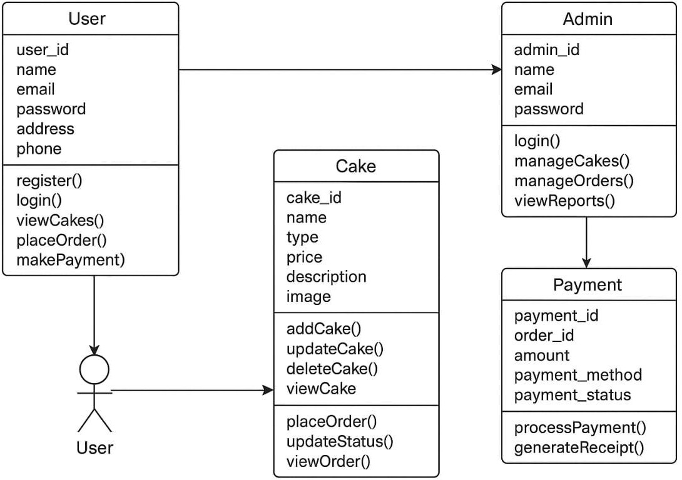

* 1. **Use Case Diagram:**

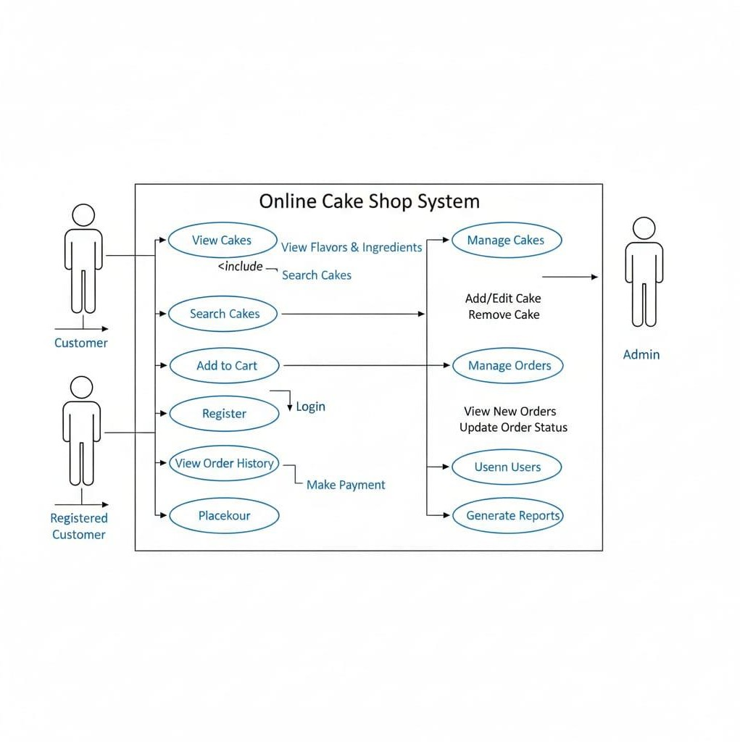

* 1. **Sequence Diagram:**



* 1. **Activity Based Diagram (user side):**

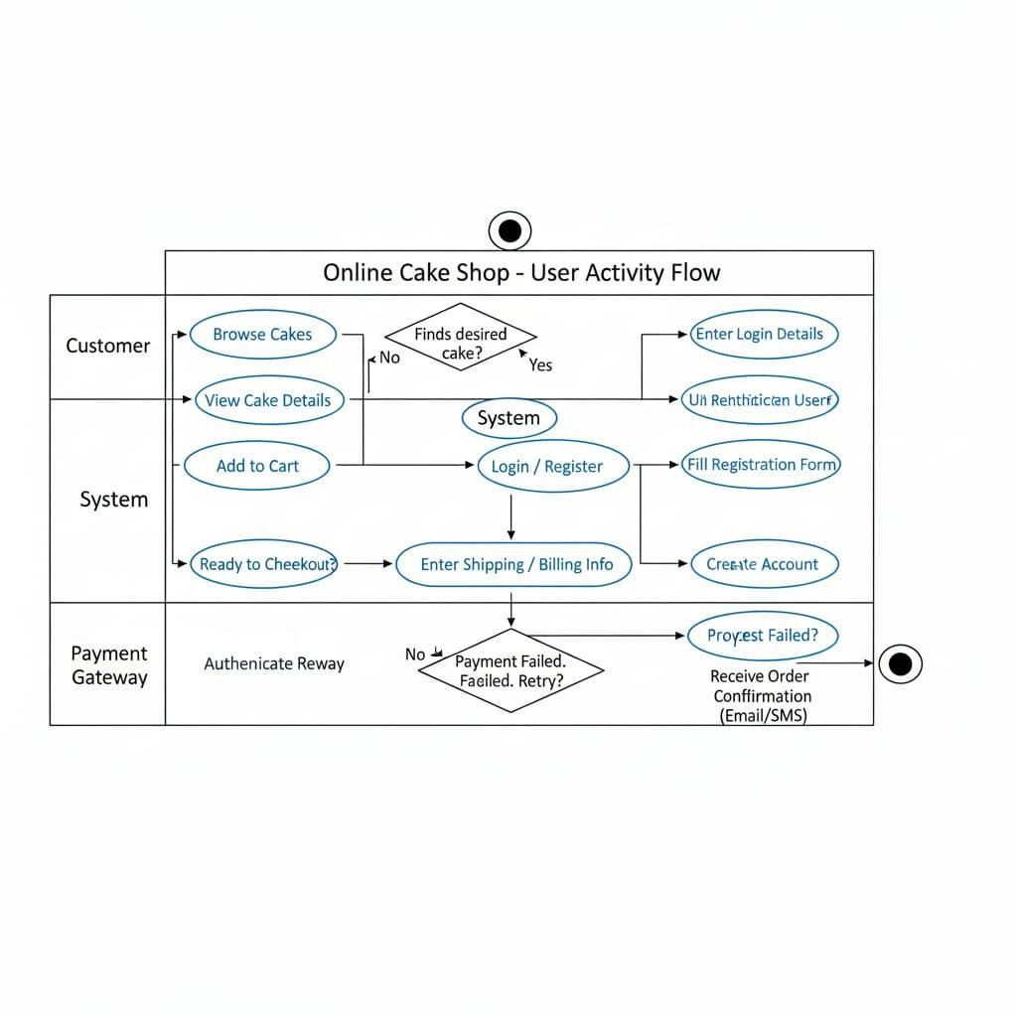

* 1. **Activity Diagram (admin side):**

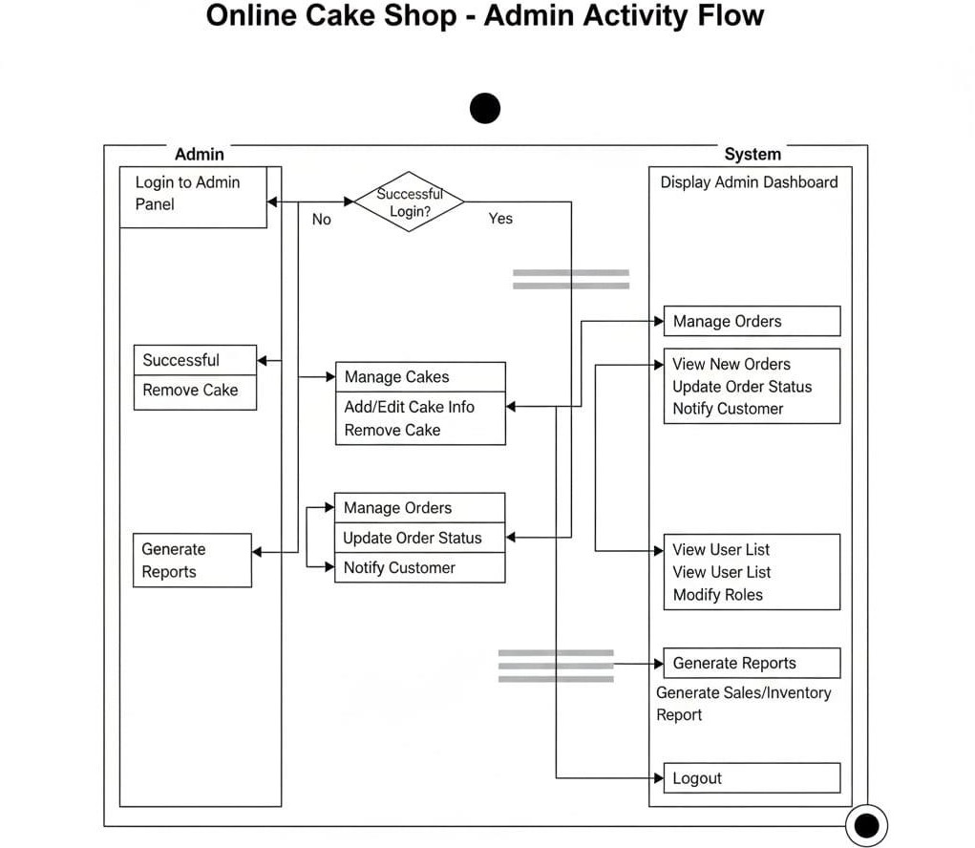

* 1. **State Diagram (user side):**

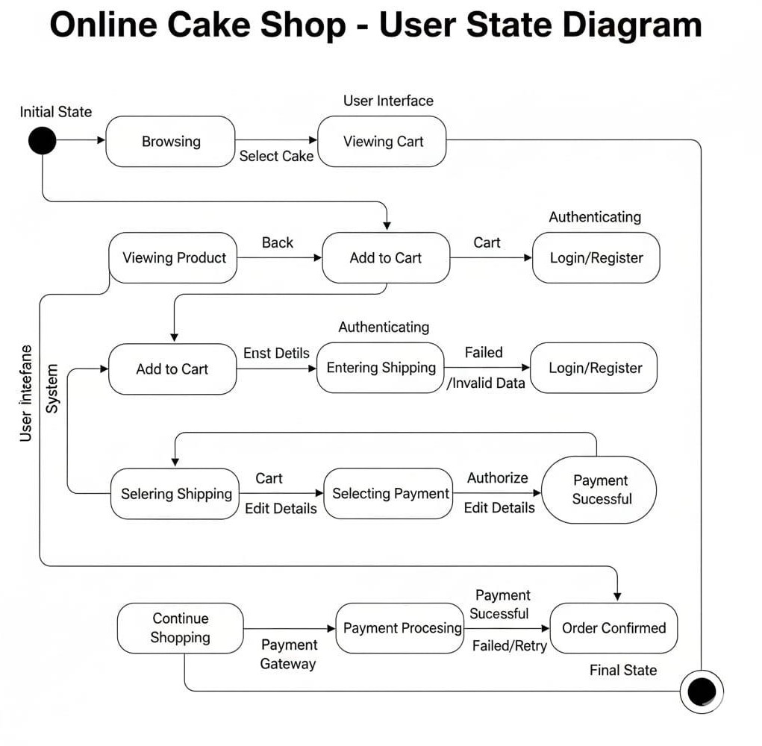

* 1. **State Diagram (admin side):**

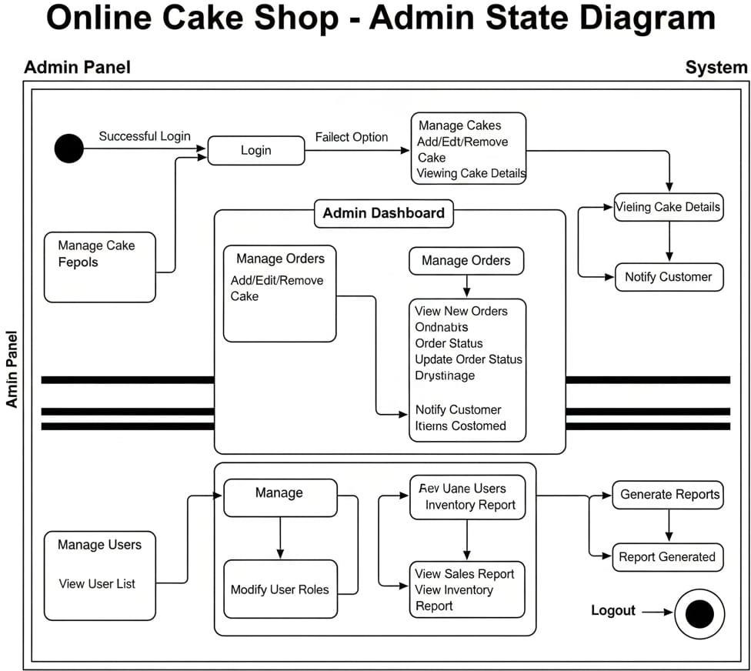

* 1. **Package Diagram:**



* 1. **Component Diagram:**

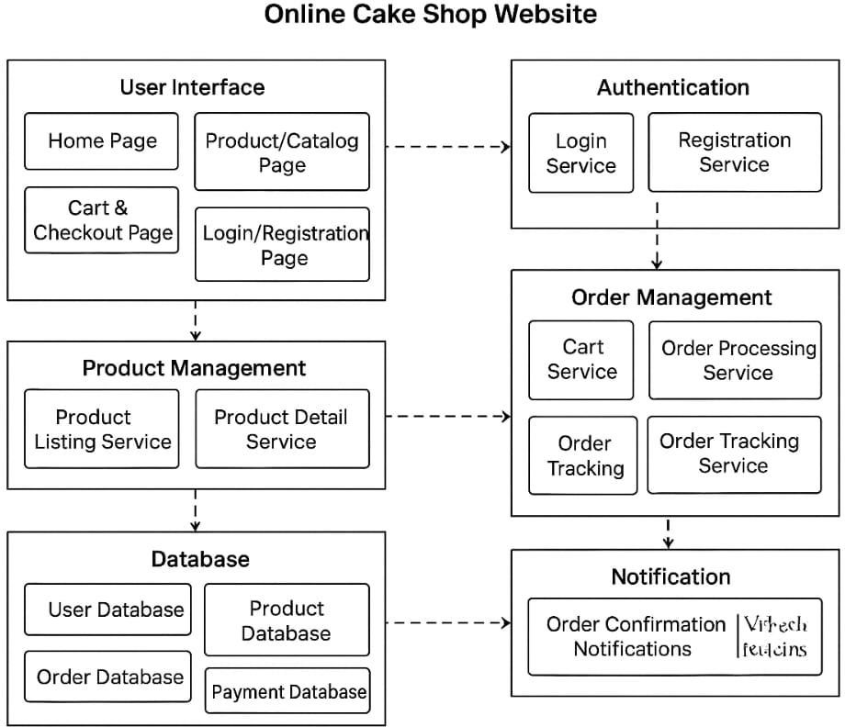

* 1. **ER Diagram:**

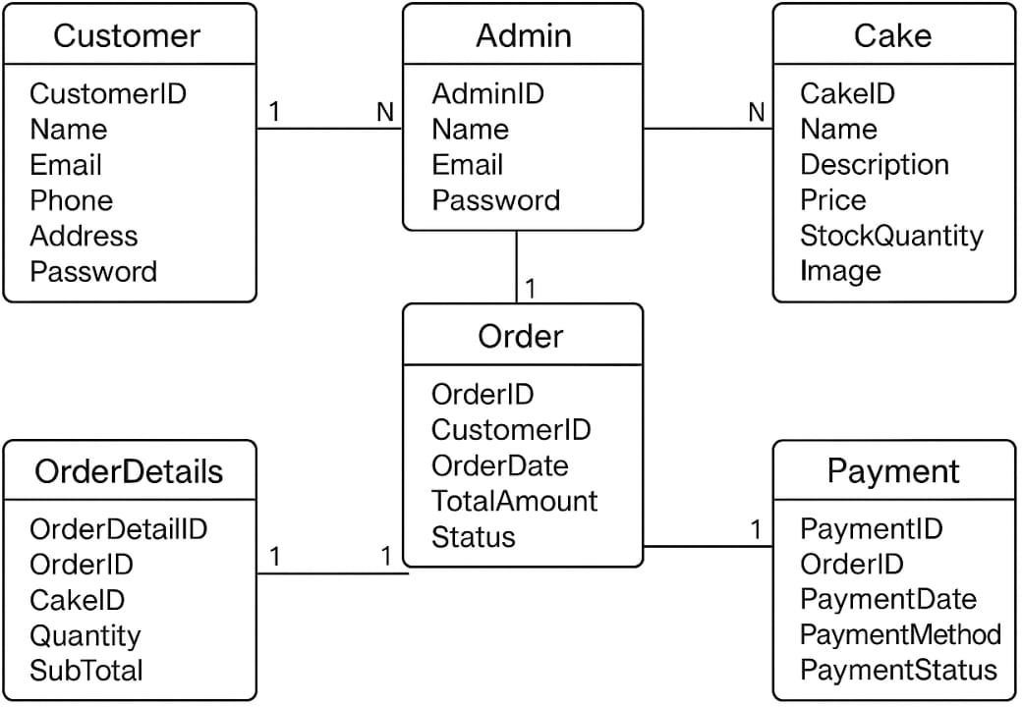

**6. TESTING**

Testing is the non-negotiable phase that verifies the CakeZone platform is not just functional, but reliable, and intuitive for the end-user. Our strategy employed both functional verification to meet technical specifications and usability testing to ensure maximum customer satisfaction.

6.1 **Functional Testing**

Functional testing was meticulously conducted to confirm that every required feature of the CakeZone website operates exactly as specified. This process verified the integrity of the data flow and the accuracy of the business logic built within the Django framework.

Purpose: To systematically verify that all specified application features—from user authentication to Cash on Delivery (COD) checkout—perform their intended actions correctly and reliably.

6.2 **Usability Testing**

Usability testing ensures the CakeZone application is easy and enjoyable to use. This testing focused on the human element, guaranteeing the interface promotes effortless ordering for the customer.

Purpose: To assess the efficiency, learnability, and overall satisfaction derived from interacting with the website's user interface and navigation structure.

7. **TEST CASES**

This section presents structured evidence of the testing performed, demonstrating that critical business and user workflows were rigorously validated. The following tables outline the execution results for the most crucial application features.

7.1 **User Registration and Login**

These cases confirm the reliability and security of the primary authentication mechanisms.

|  |  |  |
| --- | --- | --- |
| Feature | Test Case Description | Expected Result |
| Registration | Verify successful user registration with valid, unique details (name, email, password, phone). | User is successfully registered and either logged in or redirected to the login page with a success confirmation message. |
| Login | Verify successful user login with correct email and password. | User is authenticated and redirected to their account dashboard or the home page. |
| Login Failure | Verify failure upon attempting login with a correct email but an incorrect password. | System displays a standard security error message (e.g., "Invalid credentials"). |

7.2 **Customization and Ordering**

These cases validate the core product configuration and transaction integrity.

|  |  |  |
| --- | --- | --- |
| Feature | Test Case Description | Expected Result |
| Customization | Verify the user can input a custom text message (e.g., "Happy Birthday") for cake inscription. | The custom message is accurately captured and reflected in the cart and the final order summary. |
| Customization Validation | Verify adding a cake to the cart without selecting a required option (e.g., weight) triggers a prompt. | A clear error prompt asks the user to select the missing mandatory option before proceeding. |
| Cart Update | Verify the user can increase/decrease the quantity of an item already in the cart. | Quantity updates immediately, and the item's subtotal recalculates correctly. |
| Cart Removal | Verify the user can successfully remove an item from the cart. | The item disappears, and the cart's overall subtotal recalculates accurately. |

**7.3 Project Browsing and Search**

These cases ensure customers can effectively and efficiently locate desired products within the CakeZone catalogue.

|  |  |  |
| --- | --- | --- |
| Feature | Test Case Description | Expected Result |
| Category Listing | Verify clicking a main cake category (e.g., Birthday, Anniversary) displays only the relevant cakes. | The product listing page successfully filters and displays all items belonging to the selected category. |
| Keyword Search | Verify the search functionality returns correct results when searching by a cake name or flavor (e.g., "Chocolate"). | The result page displays all products that match the search term in their name or description. |
| Product Page | Verify a product detail page displays all necessary information, including base price and customization options. | All product specifications, high-resolution images, and customization inputs are present and correct. |

7.4 **Checkout and Payment (Cash on Delivery Focused)**

These cases validate the secure submission of the order and the successful initiation of the Cash on Delivery process.

|  |  |  |
| --- | --- | --- |
| Feature | Test Case Description | Expected Result |
| Delivery Address Validation | Verify the user can enter and select a valid delivery address with all mandatory fields (street, city, pin code) completed. | The system accepts the address and proceeds to the final order confirmation step. |
| COD Payment Selection | Verify the user can successfully select the Cash on Delivery (COD) option at checkout. | The COD option is selected, and the system prepares the order for submission without requiring immediate payment. |
| Order Submission | Verify the system successfully submits the order upon selecting COD and confirming the final details. | An Order Confirmation Page is displayed with a unique Order ID, and a confirmation email/notification is sent to the user. |
| Order Confirmation | Verify the order confirmation page accurately displays the unique Order ID, the total amount due (to be paid on delivery), the custom message, and the correct delivery address. | All final order details are accurate, complete, and match the information submitted by the customer. |

**7. SYSTEM IMPLEMENTATION**

**A. Frontend**

**7.1** **Base Page**

<!DOCTYPE html>

<html lang="en">

<head>

    <meta charset="UTF-8">

    <meta name="viewport" content="width=device-width, initial-scale=1.0">

    <title>{% block title %}Cake Shop{% endblock %}</title>

    <link href="https://cdn.jsdelivr.net/npm/bootstrap@5.3.8/dist/css/bootstrap.min.css" rel="stylesheet"

        integrity="sha384-sRIl4kxILFvY47J16cr9ZwB07vP4J8+LH7qKQnuqkuIAvNWLzeN8tE5YBujZqJLB" crossorigin="anonymous">

</head>

<body>

    <div class="container-fluid">

        <!-- Navbar Section -->

        <div class="row">

            <nav class="navbar navbar-expand-lg bg-black " data-bs-theme="dark">

                <div class="container-fluid">

                    {% if user.is_authenticated %}

                    <a href="/app/home" class="navbar-brand text-light"><i class="bi bi-cart-fill ">CakeZone</i></a>

                    {% else %}

                    <a href="/" class="navbar-brand text-light"><i class="bi bi-cart-fill ">CakeZone</i></a>

                    {% endif %}

                    <button class="navbar-toggler" type="button" data-bs-toggle="collapse"

                        data-bs-target="#navbarSupportedContent" aria-controls="navbarSupportedContent"

                        aria-expanded="false" aria-label="Toggle navigation">

                        <span class="navbar-toggler-icon"></span>

                    </button>

                    <div class="collapse navbar-collapse" id="navbarSupportedContent">

                        <ul class="navbar-nav me-auto mb-2 mb-lg-0">

                            <li class="nav-item">

                                {% if user.is_authenticated %}

                                <a class="nav-link active text-light nav-underline" aria-current="page"

                                    href="/app/home">Home</a>

                                {% else %}

                                <a class="nav-link active text-light nav-underline" aria-current="page"

                                    href="/">Home</a>

                                {% endif %}

                            </li>

                            <li class="nav-item">

                                <a class="nav-link text-light" href="/app/about">About</a>

                            </li>

                            <li class="nav-item">

                                <a class="nav-link text-light" href="/app/contact">Contact</a>

                            </li>

                        </ul>

                        {% if user.is_authenticated %}

                        <div class="d-flex">

                            <button class="btn btn-primary mx-2">

                                <a href="{% url 'view_cart' %}" class=" nav-link btn btn-primary position-relative">

                                    <svg xmlns="http://www.w3.org/2000/svg" width="20" height="20" fill="currentColor"

                                        class="bi bi-cart-fill text-light" viewBox="0 0 16 16">

                                        <path

                                            d="M0 1.5A.5.5 0 0 1 .5 1H2a.5.5 0 0 1 .485.379L2.89 3H14.5a.5.5 0 0 1 .491.592l-1.5 8A.5.5 0 0 1 13 12H4a.5.5 0 0 1-.491-.408L2.01 3.607 1.61 2H.5a.5.5 0 0 1-.5-.5M5 12a2 2 0 1 0 0 4 2 2 0 0 0 0-4m7 0a2 2 0 1 0 0 4 2 2 0 0 0 0-4m-7 1a1 1 0 1 1 0 2 1 1 0 0 1 0-2m7 0a1 1 0 1 1 0 2 1 1 0 0 1 0-2" />

                                    </svg>

                                    <!-- <span class="badge bg-danger">{{ cart_count }}</span> -->

                                    <span

                                        class="position-absolute top-0 start-100 translate-middle badge rounded-pill bg-danger">

                                        {{ cart_count }}

                                        <span class="visually-hidden">Cart itmes</span>

                                    </span>

                                </a>

                            </button>

                        </div>

                        <div class="d-flex">

                            <form class="d-flex" role="search" action="{% url 'search_view_name' %}" method="get" >

                                <input class="form-control me-2" type="search" placeholder="Search"

                                    aria-label="Search" type="text" name="q" value="{{ query|default:'' }}" />

                                <button class="btn btn-outline-light" type="submit"><svg

                                        xmlns="http://www.w3.org/2000/svg" width="20" height="20" fill="currentColor"

                                        class="bi bi-search" viewBox="0 0 16 16">

                                        <path

                                            d="M11.742 10.344a6.5 6.5 0 1 0-1.397 1.398h-.001q.044.06.098.115l3.85 3.85a1 1 0 0 0 1.415-1.414l-3.85-3.85a1 1 0 0 0-.115-.1zM12 6.5a5.5 5.5 0 1 1-11 0 5.5 5.5 0 0 1 11 0" />

                                    </svg></button>

                            </form>

                        </div>

                        <div class="d-flex">

                            <form action="/app/logout/" method="post">

                                {% csrf_token %}

                                <button type='submit' class="btn btn-danger mx-2"><svg

                                        xmlns="http://www.w3.org/2000/svg" width="20" height="20" fill="currentColor"

                                        class="bi bi-box-arrow-in-right" viewBox="0 0 16 16">

                                        <path fill-rule="evenodd"

                                            d="M6 3.5a.5.5 0 0 1 .5-.5h8a.5.5 0 0 1 .5.5v9a.5.5 0 0 1-.5.5h-8a.5.5 0 0 1-.5-.5v-2a.5.5 0 0 0-1 0v2A1.5 1.5 0 0 0 6.5 14h8a1.5 1.5 0 0 0 1.5-1.5v-9A1.5 1.5 0 0 0 14.5 2h-8A1.5 1.5 0 0 0 5 3.5v2a.5.5 0 0 0 1 0z" />

                                        <path fill-rule="evenodd"

                                            d="M11.854 8.354a.5.5 0 0 0 0-.708l-3-3a.5.5 0 1 0-.708.708L10.293 7.5H1.5a.5.5 0 0 0 0 1h8.793l-2.147 2.146a.5.5 0 0 0 .708.708z" />

                                    </svg></button>

                            </form>

                        </div>

                        {% else %}

                        <div class="d-flex">

                            <a href="/app/register" class="btn btn-outline-light">Register</a>

                            <a href="/app/login" class="btn btn-light" style="margin-left: 10px;">Login</a>

                        </div>

                        {% endif %}

                    </div>

                </div>

            </nav>

        </div>

        {% if messages %}

        <div class="container mt-3">

            {% for message in messages %}

            <div class="alert alert-{{ message.tags }} alert-dismissible fade show" role="alert">

                {{ message }}

                <button type="button" class="btn-close" data-bs-dismiss="alert"></button>

            </div>

            {% endfor %}

        </div>

        {% endif %}

        {% block content %}{% endblock %}

        <!-- Footer Section -->

        <div class="row">

            <div class="col container bg-dark text-light pb-4">

                <div class="container pt-3">

                    <h5>CakeZone | cakezone999@gmail.com | +91 94 7365 9033</h3>

                        <p>You can refer to the below social handles so that we can always there for you whenever

                            you're

                            celebrating the events</p>

                        <div class="container d-flex flex-row mb-3">

                            <div class="p-2">

                                <svg xmlns="http://www.w3.org/2000/svg" width="16" height="16" fill="currentColor"

                                    class="bi bi-facebook" viewBox="0 0 16 16">

                                    <path

                                        d="M16 8.049c0-4.446-3.582-8.05-8-8.05C3.58 0-.002 3.603-.002 8.05c0 4.017 2.926 7.347 6.75 7.951v-5.625h-2.03V8.05H6.75V6.275c0-2.017 1.195-3.131 3.022-3.131.876 0 1.791.157 1.791.157v1.98h-1.009c-.993 0-1.303.621-1.303 1.258v1.51h2.218l-.354 2.326H9.25V16c3.824-.604 6.75-3.934 6.75-7.951" />

                                </svg> cakezone999_facebook

                            </div>

                            <div class="p-2">

                                <svg xmlns="http://www.w3.org/2000/svg" width="16" height="16" fill="currentColor"

                                    class="bi bi-instagram" viewBox="0 0 16 16">

                                    <path

                                        d="M8 0C5.829 0 5.556.01 4.703.048 3.85.088 3.269.222 2.76.42a3.9 3.9 0 0 0-1.417.923A3.9 3.9 0 0 0 .42 2.76C.222 3.268.087 3.85.048 4.7.01 5.555 0 5.827 0 8.001c0 2.172.01 2.444.048 3.297.04.852.174 1.433.372 1.942.205.526.478.972.923 1.417.444.445.89.719 1.416.923.51.198 1.09.333 1.942.372C5.555 15.99 5.827 16 8 16s2.444-.01 3.298-.048c.851-.04 1.434-.174 1.943-.372a3.9 3.9 0 0 0 1.416-.923c.445-.445.718-.891.923-1.417.197-.509.332-1.09.372-1.942C15.99 10.445 16 10.173 16 8s-.01-2.445-.048-3.299c-.04-.851-.175-1.433-.372-1.941a3.9 3.9 0 0 0-.923-1.417A3.9 3.9 0 0 0 13.24.42c-.51-.198-1.092-.333-1.943-.372C10.443.01 10.172 0 7.998 0zm-.717 1.442h.718c2.136 0 2.389.007 3.232.046.78.035 1.204.166 1.486.275.373.145.64.319.92.599s.453.546.598.92c.11.281.24.705.275 1.485.039.843.047 1.096.047 3.231s-.008 2.389-.047 3.232c-.035.78-.166 1.203-.275 1.485a2.5 2.5 0 0 1-.599.919c-.28.28-.546.453-.92.598-.28.11-.704.24-1.485.276-.843.038-1.096.047-3.232.047s-2.39-.009-3.233-.047c-.78-.036-1.203-.166-1.485-.276a2.5 2.5 0 0 1-.92-.598 2.5 2.5 0 0 1-.6-.92c-.109-.281-.24-.705-.275-1.485-.038-.843-.046-1.096-.046-3.233s.008-2.388.046-3.231c.036-.78.166-1.204.276-1.486.145-.373.319-.64.599-.92s.546-.453.92-.598c.282-.11.705-.24 1.485-.276.738-.034 1.024-.044 2.515-.045zm4.988 1.328a.96.96 0 1 0 0 1.92.96.96 0 0 0 0-1.92m-4.27 1.122a4.109 4.109 0 1 0 0 8.217 4.109 4.109 0 0 0 0-8.217m0 1.441a2.667 2.667 0 1 1 0 5.334 2.667 2.667 0 0 1 0-5.334" />

                                </svg> cakezone999_insta

                            </div>

                            <div class="p-2">

                                <svg xmlns="http://www.w3.org/2000/svg" width="16" height="16" fill="currentColor"

                                    class="bi bi-twitter-x" viewBox="0 0 16 16">

                                    <path

                                        d="M12.6.75h2.454l-5.36 6.142L16 15.25h-4.937l-3.867-5.07-4.425 5.07H.316l5.733-6.57L0 .75h5.063l3.495 4.633L12.601.75Zm-.86 13.028h1.36L4.323 2.145H2.865z" />

                                </svg> cakezone999_twit

                            </div>

                        </div>

                        <div class="container m-4">

                            We have different varities of flavours which you can enjoy

                            <hr>

                            <ul>

                                <li>Black Forest</li>

                                <li>Hazzlenut</li>

                                <li>Fruits and almonds</li>

                                <li>Rasamalai</li>

                            </ul>

                            <hr>

                            <ul>

                                <li>Choco Lava</li>

                                <li>Lemon Cake</li>

                                <li>Red Velvet</li>

                                <li>ButterScotch</li>

                            </ul>

                        </div>

                        <!-- <p>And much more you if you wanna taste this flavours of cake and want to know more about the

                            new varities</p>

                        <p>Then, please submit your email here:</p>

                        <form action="/takeemail" method="post" class="container-sm">

                            <input type="email" name="emailcheck" id="emailcheck" class="form-control"

                                placeholder="Enter your email" style="width: 40%;" />

                            <button class="btn btn-primary mt-4">Submit</button>

                        </form> -->

                </div>

            </div>

        </div>

    </div>

    <script src="https://cdn.jsdelivr.net/npm/bootstrap@5.3.8/dist/js/bootstrap.bundle.min.js"

        integrity="sha384-FKyoEForCGlyvwx9Hj09JcYn3nv7wiPVlz7YYwJrWVcXK/BmnVDxM+D2scQbITxI"

        crossorigin="anonymous"></script>

</body>

</html>

**7.2** **Register Page**

<!DOCTYPE html>

<html lang="en">

<head>

  <meta charset="UTF-8">

  <meta name="viewport" content="width=device-width, initial-scale=1.0">

  <title>Register</title>

  <link href="https://cdn.jsdelivr.net/npm/bootstrap@5.3.8/dist/css/bootstrap.min.css" rel="stylesheet">

  <style>

    body {

      background: linear-gradient(90deg, #1e3c72, white);

      min-height: 100vh;

      display: flex;

      justify-content: center;

      align-items: center;

    }

    .register-container {

      background: #fff;

      border-radius: 10px;

      overflow: hidden;

      display: flex;

      max-width: 900px;

      width: 100%;

      box-shadow: 0 10px 30px rgba(0,0,0,0.3);

    }

    .register-image {

      flex: 1;

      background-size: cover;

      background-position: center;

    }

    .register-form {

      flex: 1;

      padding: 40px;

    }

    .register-form h2 {

      margin-bottom: 30px;

      font-weight: 600;

      text-align: center;

      color: #333;

    }

    .register-form .btn {

      background-color: #ff7a00;

      border: none;

      color: white;

    }

    .register-form .btn:hover {

      background-color: #e06c00;

    }

    @media (max-width: 768px) {

      .register-container {

        flex-direction: column;

      }

      .register-image {

        height: 200px;

      }

    }

  </style>

</head>

<body>

<div class="register-container">

  <!-- Left Image -->

  <div class="register-image" style="background-image: url('/static/cakeapp/img5.jpg');">

  </div>

  <!-- Right Form -->

  <div class="register-form">

    <h2>Register</h2>

    <form method="post" novalidate>

      {% csrf_token %}

      {{ form.non_field_errors }}

      <div class="mb-3">

        {{ form.username.label_tag }}

        {{ form.username }}

        <div class="text-danger small">{{ form.username.errors }}</div>

      </div>

      <div class="mb-3">

        {{ form.email.label_tag }}

        {{ form.email }}

        <div class="text-danger small">{{ form.email.errors }}</div>

      </div>

      <div class="mb-3">

        {{ form.password1.label_tag }}

        {{ form.password1 }}

        <div class="text-danger small">{{ form.password1.errors }}</div>

      </div>

      <div class="mb-3">

        {{ form.password2.label_tag }}

        {{ form.password2 }}

        <div class="text-danger small">{{ form.password2.errors }}</div>

      </div>

      <button type="submit" class="btn w-100">Register</button>

      <p class="mt-3 text-center">

        Already have an account? <a href="{% url 'login' %}">Login</a>

      </p>

    </form>

  </div>

</div>

</body>

</html>

**7.3 Login Page**

<!DOCTYPE html>

<html lang="en">

<head>

  <meta charset="UTF-8">

  <meta name="viewport" content="width=device-width, initial-scale=1.0">

  <title>Login</title>

  <link href="https://cdn.jsdelivr.net/npm/bootstrap@5.3.8/dist/css/bootstrap.min.css" rel="stylesheet">

  <style>

    body {

      background: linear-gradient(90deg, orange, white);

      min-height: 100vh;

      display: flex;

      justify-content: center;

      align-items: center;

    }

    .register-container {

      background: #fff;

      border-radius: 10px;

      overflow: hidden;

      display: flex;

      max-width: 900px;

      width: 100%;

      box-shadow: 0 10px 30px rgba(0, 0, 0, 0.3);

    }

    .register-image {

      flex: 1;

      background-size: cover;

      background-position: center;

    }

    .register-form {

      flex: 1;

      padding: 40px;

    }

    .register-form h2 {

      margin-bottom: 30px;

      font-weight: 600;

      text-align: center;

      color: #1c1717;

    }

    .register-form h6 {

      margin-bottom: 20px;

      font-weight: 600;

      text-align: center;

      color: #333;

      font-family: 'Segoe UI', Tahoma, Geneva, Verdana, sans-serif;

    }

    .register-form .btn {

      background-color: #ff7a00;

      border: none;

      color: white;

    }

    .register-form .btn:hover {

      background-color: #e06c00;

    }

    @media (max-width: 768px) {

      .register-container {

        flex-direction: column;

      }

      .register-image {

        height: 200px;

      }

    }

  </style>

</head>

<body class="bg-dark text-light">

  {% if messages %}

  <div class="container mt-3">

    {% for message in messages %}

    <div class="alert alert-{{ message.tags }} alert-dismissible fade show" role="alert">

      {{ message }}

      <button type="button" class="btn-close" data-bs-dismiss="alert" aria-label="Close"></button>

    </div>

    {% endfor %}

  </div>

  {% endif %}

  <div class="register-container">

    <!-- Left Image -->

    <div class="register-image" style="background-image: url('/static/cakeapp/img6.jpg');">

    </div>

    <!-- Right Form -->

    <div class="register-form">

      <h2>Welcome</h2>

      <h6>Please login here</h6>

      <form method="post" novalidate>

        {% csrf_token %}

        {{ form.non_field_errors }}

        <div class="mb-3 text-dark">

          {{ form.username.label_tag }}

          {{ form.username }}

          {{ form.username.errors }}

        </div>

        <div class="mb-3 text-dark">

          {{ form.password.label_tag }}

          {{ form.password }}

          {{ form.password.errors }}

        </div>

        <button type="submit" class="btn btn-primary w-100">Login</button>

        <p class="mt-3 text-center text-dark">

          Don't have account yet?<a href="{% url 'register' %}">Register</a>

        </p>

      </form>

    </div>

  </div>

  <script src="https://cdn.jsdelivr.net/npm/bootstrap@5.3.8/dist/js/bootstrap.bundle.min.js"></script>

</body>

</html>

7.4 **Contact Page:**

{% extends "base.html" %}

{% block title %}Home - Cake Shop{% endblock %}

{% block content %}

<main class="py-5 py-lg-5">

        <div class="container px-4 px-sm-6 px-lg-8">

            <div class="text-center mb-5">

                <h1 class="text-uppercase fw-semibold text-pink small">Get in Touch</h1>

                <p class="mt-2 display-5 fw-bolder text-dark">

                    We're Ready to Help!

                </p>

                <p class="mt-3 fs-5 text-secondary mx-auto col-lg-8">

                    Whether you have a custom order request, a question about ingredients, or just want to say hello, we look forward to hearing from you.

                </p>

            </div>

            <div class="card shadow-lg border-0 rounded-4 overflow-hidden">

                <div class="row g-0">

                    <div class="col-lg-6 p-4 p-sm-5 p-lg-5 hover-scale">

                        <h2 class="h3 fw-bold text-dark mb-4">Send Us a Message</h2>

                        <form id="contactForm" onsubmit="handleFormSubmit(event)" class="needs-validation" novalidate>

                            <div class="mb-3">

                                <label for="name" class="form-label fw-medium text-dark">Full Name</label>

                                <input type="text" name="name" id="name" class="form-control form-control-lg rounded-3" required>

                                <div class="invalid-feedback">Please enter your name.</div>

                            </div>

                            <div class="mb-3">

                                <label for="email" class="form-label fw-medium text-dark">Email Address</label>

                                <input type="email" name="email" id="email" class="form-control form-control-lg rounded-3" required>

                                <div class="invalid-feedback">Please enter a valid email address.</div>

                            </div>

                            <div class="mb-3">

                                <label for="subject" class="form-label fw-medium text-dark">Subject / Order Type</label>

                                <input type="text" name="subject" id="subject" class="form-control form-control-lg rounded-3" required>

                                <div class="invalid-feedback">Please enter a subject.</div>

                            </div>

                            <div class="mb-4">

                                <label for="message" class="form-label fw-medium text-dark">Your Message</label>

                                <textarea id="message" name="message" rows="4" class="form-control rounded-3" required></textarea>

                                <div class="invalid-feedback">Please enter your message.</div>

                            </div>

                            <div id="statusMessage" class="text-center fw-medium mt-3 alert alert-success d-none" role="alert"></div>

                            <button type="submit"

                                class="btn btn-pink btn-lg w-100 rounded-3 shadow-sm transition duration-300">

                                Submit Request

                            </button>

                        </form>

                    </div>

                    <div class="col-lg-6 p-4 p-sm-5 p-lg-5 bg-pink-light d-flex flex-column justify-content-between hover-scale">

                        <div>

                            <h2 class="h3 fw-bold text-pink mb-4">Our Information</h2>

                            <div class="d-grid gap-4">

                                <div class="d-flex">

                                    <svg class="flex-shrink-0 me-3 mt-1 text-pink" width="24" height="24" viewBox="0 0 24 24" fill="none" stroke="currentColor" stroke-width="2" stroke-linecap="round" stroke-linejoin="round"><path d="M21 10c0 7-9 13-9 13s-9-6-9-13a9 9 0 0118 0z"/><circle cx="12" cy="10" r="3"/></svg>

                                    <div>

                                        <h3 class="fs-5 fw-medium text-pink">Visit Our Shop</h3>

                                        <p class="mb-0 text-dark">123 Cake Lane, Sweet City, CA 90210</p>

                                        <p class="mb-0 text-dark">Mon - Sat: 9:00 AM - 5:00 PM</p>

                                    </div>

                                </div>

                                <div class="d-flex">

                                    <svg class="flex-shrink-0 me-3 mt-1 text-pink" width="24" height="24" viewBox="0 0 24 24" fill="none" stroke="currentColor" stroke-width="2" stroke-linecap="round" stroke-linejoin="round"><path d="M4 4h16c1.1 0 2 .9 2 2v12c0 1.1-.9 2-2 2H4c-1.1 0-2-.9-2-2V6c0-1.1.9-2 2-2z"/><polyline points="22,6 12,13 2,6"/></svg>

                                    <div>

                                        <h3 class="fs-5 fw-medium text-pink">Email Us</h3>

                                        <p class="mb-0 text-dark"><a href="mailto:orders@artisanbakery.com" class="text-dark text-decoration-none hover-link-pink">orders@artisanbakery.com</a></p>

                                    </div>

                                </div>

                                <div class="d-flex">

                                    <svg class="flex-shrink-0 me-3 mt-1 text-pink" width="24" height="24" viewBox="0 0 24 24" fill="none" stroke="currentColor" stroke-width="2" stroke-linecap="round" stroke-linejoin="round"><path d="M22 16.92v3a2 2 0 01-2.18 2 19.79 19.79 0 01-8.63-3.07 19.5 19.5 0 01-6.7-6.7A19.79 19.79 0 012.08 4.18a2 2 0 012-2.18h3a2 2 0 012 1.72 12.84 12.84 0 00.7 2.81 2 2 0 01-.45 2.11L8.09 9.91a16 16 0 006 6l1.27-1.27a2 2 0 012.11-.45 12.84 12.84 0 002.81.7A2 2 0 0122 16.92z"/></svg>

                                    <div>

                                        <h3 class="fs-5 fw-medium text-pink">Call Us</h3>

                                        <p class="mb-0 text-dark"><a href="tel:+15551234567" class="text-dark text-decoration-none hover-link-pink">(555) 123-4567</a></p>

                                    </div>

                                </div>

                            </div>

                        </div>

                        <div class="mt-5">

                            <h3 class="fs-5 fw-medium text-pink mb-2">Our Location</h3>

                            <div class="p-4 bg-white rounded-3 shadow-sm border border-pink text-center" style="height: 12rem;">

                                <p class="text-pink fw-semibold m-0">Map Placeholder</p>

                            </div>

                        </div>

                    </div>

                </div>

            </div>

        </div>

    </main>

{%endblock%}

7.5 **About Page**

{% extends "base.html" %}

{% block title %}Home - Cake Shop{% endblock %}

{% block content %}

<main>

        <!-- Hero Section (Jumbotron style) -->

        <section class="py-5 py-md-5 bg-pink-light overflow-hidden">

            <div class="container px-4 px-sm-6 px-lg-8 text-center">

                <h1 class="display-3 fw-bolder text-dark">

                    Our Story: Crafting Moments, One Cake at a Time

                </h1>

                <p class="mt-4 fs-5 text-secondary mx-auto col-lg-8">

                    We believe that the best cakes are made with passion, high-quality ingredients, and a commitment to artistry. Learn about the journey that brought us here.

                </p>

            </div>

        </section>

        <!-- The Story Section -->

        <section class="py-5 py-md-5 bg-white">

            <div class="container px-4 px-sm-6 px-lg-8">

                <div class="row align-items-center g-5">

                    <div class="col-lg-6">

                        <h2 class="display-6 fw-bold text-pink">

                            From Humble Beginnings to Culinary Excellence

                        </h2>

                        <p class="mt-4 lead text-secondary">

                            Our founder, Clara, started baking in her small kitchen in 2010 with a single goal: to share the joy of truly exceptional, homemade treats. That passion quickly grew into Artisan Bakery, a recognized name for bespoke wedding cakes and daily delights.

                        </p>

                        <p class="mt-3 lead text-secondary">

                            We never compromise on quality, using only locally sourced, natural ingredients and time-honored techniques. Every item on our menu is a labor of love, designed not just to taste good, but to create lasting memories.

                        </p>

                    </div>

                    <div class="col-lg-6">

                        <!-- Placeholder Image with shadow and rounded corners -->

                        <img class="img-fluid rounded-4 shadow-lg hover-scale"

                             src="/static/cakeapp/kitchen.jpg"

                             alt="Picture representing the history of the bakery" style="object-fit: cover;">

                    </div>

                </div>

            </div>

        </section>

        <!-- Mission and Values Section -->

        <section class="py-5 py-md-5 bg-pink-light">

            <div class="container px-4 px-sm-6 px-lg-8">

                <div class="text-center mb-5">

                    <h2 class="text-uppercase text-pink fw-semibold small">Our Core Beliefs</h2>

                    <p class="mt-2 display-6 fw-bolder text-dark">

                        What Drives Our Dedication

                    </p>

                </div>

                <div class="row g-4 mt-4">

                    <!-- Value 1 -->

                    <div class="col-md-4">

                        <div class="card border-0 rounded-4 shadow h-100 text-center p-4 hover-scale">

                            <div class="card-body">

                                <svg class="text-pink mb-3" width="40" height="40" fill="none" viewBox="0 0 24 24" stroke="currentColor" stroke-width="2" stroke-linecap="round" stroke-linejoin="round">

                                    <path d="M3 15a4 4 0 004 4h9a5 5 0 10-.1-9.999 5.002 5.002 0 10-9.78 2.096A4.001 4.001 0 003 15z" />

                                </svg>

                                <h5 class="card-title fw-bold text-dark">Unwavering Quality</h5>

                                <p class="card-text text-secondary">

                                    We use the finest ingredients—organic butter, free-range eggs, and gourmet cocoa—to ensure every bite is perfection.

                                </p>

                            </div>

                        </div>

                    </div>

                    <!-- Value 2 -->

                    <div class="col-md-4">

                        <div class="card border-0 rounded-4 shadow h-100 text-center p-4 hover-scale">

                            <div class="card-body">

                                <svg class="text-pink mb-3" width="40" height="40" fill="none" viewBox="0 0 24 24" stroke="currentColor" stroke-width="2" stroke-linecap="round" stroke-linejoin="round">

                                    <path d="M13 10V3L4 14h7v7l9-11h-7z" />

                                </svg>

                                <h5 class="card-title fw-bold text-dark">Artisan Craftsmanship</h5>

                                <p class="card-text text-secondary">

                                    Each cake is handcrafted by skilled decorators, turning every order into a unique piece of edible art.

                                </p>

                            </div>

                        </div>

                    </div>

                    <!-- Value 3 -->

                    <div class="col-md-4">

                        <div class="card border-0 rounded-4 shadow h-100 text-center p-4 hover-scale">

                            <div class="card-body">

                                <svg class="text-pink mb-3" width="40" height="40" fill="none" viewBox="0 0 24 24" stroke="currentColor" stroke-width="2" stroke-linecap="round" stroke-linejoin="round">

                                    <path d="M4.318 6.318a4.5 4.5 0 000 6.364L12 20.364l7.682-7.682a4.5 4.5 0 00-6.364-6.364L12 7.636l-1.318-1.318a4.5 4.5 0 00-6.364 0z" />

                                </svg>

                                <h5 class="card-title fw-bold text-dark">Customer Delight</h5>

                                <p class="card-text text-secondary">

                                    Our success is measured by the happiness of our customers. We strive to exceed expectations with every interaction.

                                </p>

                            </div>

                        </div>

                    </div>

                </div>

            </div>

        </section>

        <!-- Team Section -->

        <section class="py-5 py-md-5 bg-white">

            <div class="container px-4 px-sm-6 px-lg-8 text-center">

                <h2 class="text-uppercase text-pink fw-semibold small">The People Behind the Flour</h2>

                <p class="mt-2 display-6 fw-bolder text-dark mb-5">

                    Meet Our Dedicated Team

                </p>

                <div class="row g-4 justify-content-center">

                    <!-- Team Member 1 -->

                    <div class="col-md-6 col-lg-4">

                        <div class="card border-0 rounded-4 shadow p-4 hover-scale">

                            <img class="mx-auto d-block rounded-circle object-cover mb-4 shadow-sm"

                                 src="/static/cakeapp/2.jpeg"

                                 alt="Clara Mitchell, Founder" style="width: 150px; height: 150px;">

                            <h3 class="h4 fw-bold text-dark">Clara Mitchell</h3>

                            <p class="text-pink fw-medium mt-1 mb-2">Founder & Head Pastry Chef</p>

                            <p class="text-secondary small">

                                Clara leads our team with an inspiring blend of creativity and dedication to traditional baking excellence.

                            </p>

                        </div>

                    </div>

                    <!-- Team Member 2 -->

                    <div class="col-md-6 col-lg-4">

                        <div class="card border-0 rounded-4 shadow p-4 hover-scale">

                            <img class="mx-auto d-block rounded-circle object-cover mb-4 shadow-sm"

                                 src="/static/cakeapp/3.jpeg"

                                 alt="Alex Kim, Lead Decorator" style="width: 150px; height: 150px;">

                            <h3 class="h4 fw-bold text-dark">Alex Kim</h3>

                            <p class="text-pink fw-medium mt-1 mb-2">Lead Cake Decorator</p>

                            <p class="text-secondary small">

                                Alex is our visual wizard, transforming batter and frosting into stunning, custom-designed edible art pieces.

                            </p>

                        </div>

                    </div>

                    <!-- Team Member 3 -->

                    <div class="col-md-6 col-lg-4">

                        <div class="card border-0 rounded-4 shadow p-4 hover-scale">

                            <img class="mx-auto d-block rounded-circle object-cover mb-4 shadow-sm"

                                 src="/static/cakeapp/images.jpeg"

                                 alt="Lena Garcia, Operations Manager" style="width: 150px; height: 150px;">

                            <h3 class="h4 fw-bold text-dark">Lena Garcia</h3>

                            <p class="text-pink fw-medium mt-1 mb-2">Operations Manager</p>

                            <p class="text-secondary small">

                                Lena ensures that every order, from the initial consultation to final delivery, is executed flawlessly and on time.

                            </p>

                        </div>

                    </div>

                </div>

            </div>

        </section>

    </main>

{% endblock %}

7.6 **User Home (Page after the user login):**

{% extends "base.html" %}

{% block title %}Home - Cake Shop{% endblock %}

{% block content %}

<div class="container my-5">

    {# Make the welcome message more prominent and engaging #}

    <h2 class="display-6 mb-1">Hi {{ user.username }}, Welcome to CakeZone!</h2>

    <p class="lead text-muted mb-5">Explore our delightful collection below and find your perfect treat.</p>

    <h3 class="mt-4 border-bottom pb-2">Our Cakes</h3>

    {# ... rest of your product listing code ... #}

</div>

<style>

    /* Custom styling to make the controls smaller and less intrusive */

    .custom-carousel-control {

        position: static; /* Important: removes default absolute positioning */

        width: 30px; /* Smaller width */

        height: 30px; /* Smaller height */

        background-color: #000; /* Darker background */

        opacity: 0.7;

        border-radius: 50%; /* Make them circular */

        transition: opacity 0.15s ease;

        padding: 0;

        margin-left: 5px; /* Add some space between controls */

    }

    .custom-carousel-control:hover {

        opacity: 1;

    }

    .custom-carousel-control-icon {

        width: 15px; /* Adjust icon size */

        height: 15px; /* Adjust icon size */

    }

</style>

<div class="container my-5">

    {% for category, cakes in cakes_by_category.items %}

    <div class="d-flex justify-content-between align-items-center mb-4">

        <h5 class="text-capitalize border-bottom pb-2 mb-0" style="color: black; flex-grow: 1;">{{ category }} Cakes</h5>

        <div class="d-flex">

            <button class="custom-carousel-control" type="button" data-bs-target="#carousel-{{ forloop.counter }}" data-bs-slide="prev">

                <span class="carousel-control-prev-icon custom-carousel-control-icon" aria-hidden="true"></span>

                <span class="visually-hidden">Previous</span>

            </button>

            <button class="custom-carousel-control" type="button" data-bs-target="#carousel-{{ forloop.counter }}" data-bs-slide="next">

                <span class="carousel-control-next-icon custom-carousel-control-icon" aria-hidden="true"></span>

                <span class="visually-hidden">Next</span>

            </button>

        </div>

    </div>

    <div id="carousel-{{ forloop.counter }}" class="carousel slide mb-5" data-bs-ride="carousel">

        <div class="carousel-inner">

            {% for cake in cakes %}

                {# The logic here groups 6 cards per carousel item #}

                {% if forloop.first or forloop.counter0|divisibleby:6 %}

                <div class="carousel-item {% if forloop.first %}active{% endif %}">

                    <div class="row">

                {% endif %}

                        {# The column should be col-md-2 for 6 cards in a row #}

                        <div class="col-md-2 mb-4">

                            <div class="card h-100">

                                <img src="{{ cake.cake_image.url }}" class="card-img-top" alt="{{ cake.name }}"

                                    style="height: 200px; object-fit: cover;">

                                <div class="card-body d-flex flex-column">

                                    <h6 class="card-title fw-bold text-center">{{ cake.name }}</h6>

                                    {# Description Div: Takes up all available space to enforce button alignment #}

                                    <div class="flex-grow-1 mb-3">

                                        <p class="card-text text-muted small text-center">{{ cake.description|truncatechars:70 }}</p>

                                    </div>

                                    {# Price and button #}

                                    <div class="d-grid gap-2">

                                        <h5 class="card-text mb-0 fw-bold text-center text-dark">

                                            ₹{{ cake.price|floatformat:2 }}

                                        </h5>

                                        <a href="{% url 'add_to_cart' cake.id %}" class="btn btn-primary">

                                            Add to Cart

                                        </a>

                                    </div>

                                </div>

                            </div>

                        </div>

                {% if forloop.counter|divisibleby:6 or forloop.last %}

                    </div>

                </div>

                {% endif %}

            {% endfor %}

        </div>

        {# REMOVED: The original carousel controls are gone from here #}

    </div>

    {% endfor %}

</div>

{% endblock %}

7.7 **Cart Page**

{% extends "base.html" %}

{% block title %}Your Cart{% endblock %}

{% block content %}

<div class="container my-5">

  <h2>Your Cart</h2>

  {% if cart_items %}

    <div class="list-group"> {# Main container for the cart items #}

      {% for item in cart_items %}

      <div class="list-group-item d-flex align-items-center mb-4 p-4 border rounded shadow-sm">

        {# 1. Product Image (Increased Size) #}

        <div class="me-4 flex-shrink-0">

          {% if item.cake.cake_image %}

            <img src="{{ item.cake.cake_image.url }}" alt="{{ item.cake.name }}"

                 class="img-fluid rounded" style="width: 180px; height: 180px; object-fit: cover;"> {# Image size is now 180x180 #}

          {% else %}

            <div class="d-flex align-items-center justify-content-center bg-light text-muted rounded border"

                 style="width: 180px; height: 180px;">

              No Image

            </div>

          {% endif %}

        </div>

        {# 2. Product Details (Name, Description, Category, Veg/Non-Veg) #}

        <div class="flex-grow-1 me-4">

          <h4 class="mb-1 fw-bold">{{ item.cake.name }}</h4>

          <p class="text-muted mb-3">{{ item.cake.description|truncatechars:150 }}</p>

          {# Badges for extra info #}

          <div class="d-flex align-items-center mb-2">

            <span class="badge bg-info text-dark">{{ item.cake.category }}</span>

            <span class="badge bg-{% if item.cake.veg_nonveg == 'veg' %}success{% else %}danger{% endif %} ms-2">

              <i class="fas fa-dot-circle"></i> {{ item.cake.get_veg_nonveg_display }}

            </span>

          </div>

          {# Unit Price #}

          <p class="mb-0 text-secondary">Unit Price: <span class="fw-bold">₹{{ item.cake.price|floatformat:2 }}</span></p>

        </div>

        {# 3. Quantity Controls & Item Total #}

        <div class="d-flex flex-column align-items-center me-4 border-start ps-4">

          <label class="form-label mb-1 fw-bold text-nowrap">Quantity</label>

          <div class="input-group input-group-sm mb-3" style="width: 120px;">

            <a href="{% url 'decrease_quantity' item.id %}" class="btn btn-outline-secondary">-</a>

            <input type="text" class="form-control text-center bg-white" value="{{ item.quantity }}" readonly>

            <a href="{% url 'increase_quantity' item.id %}" class="btn btn-outline-secondary">+</a>

          </div>

          <p class="mb-0 text-nowrap">Subtotal:</p>

          <h5 class="text-success fw-bold text-nowrap">₹{{ item.item_total|floatformat:2 }}</h5>

        </div>

        {# 4. Action Button #}

        <div class="ms-3">

          <a href="{% url 'remove_from_cart' item.id %}" class="btn btn-outline-danger">Remove</a>

        </div>

      </div>

      {% endfor %}

    </div>

    <hr class="my-5">

    {# Grand Total and Checkout Button #}

    <div class="d-flex justify-content-end align-items-center">

        <h3 class="me-4 mb-0">Grand Total: <span class="text-dark fw-bold">₹{{ total|floatformat:2 }}</span></h3>

        <a href="{% url 'checkout' %}" class="btn btn-lg btn-success">Proceed to Checkout</a>

    </div>

  {% else %}

    <div class="alert alert-info text-center" role="alert">

      Your cart is empty. <a href="{% url 'home' %}">Start shopping!</a>

    </div>

  {% endif %}

</div>

{% endblock %}

**B. Backend**

7.9 **App/urls.py**

from django.contrib import admin

from django.urls import path

from . import views

from django.contrib.auth import views as auth_views

urlpatterns = [

    # App

    path('home', views.home, name="home"),

    path('cakebtn/<int:id>', views.cakebtn, name="cakebtn"),

    path('addtocart/<int:cake_id>', views.add_to_cart, name="add_to_cart"),

    path('view_cart', views.view_cart, name="view_cart"),

    path('remove_from_cart/<int:item_id>', views.remove_from_cart, name="remove_from_cart"),

    path('checkout', views.checkout, name="checkout"),

    path('increase_quantity/<int:item_id>', views.increase_quantity, name="increase_quantity"),

    path('decrease_quantity/<int:item_id>', views.decrease_quantity, name="decrease_quantity"),

    path("order-success/<int:order_id>/", views.order_success, name="order_success"),

    path("place_order/", views.place_order, name="place_order"),

    path("order_summary/<int:order_id>", views.order_summary, name="order_summary"),

     path("order/<int:order_id>/invoice/pdf/", views.generate_invoice_pdf, name="generate_invoice_pdf"),

    path("order/track/", views.order_tracker, name="order_tracker"),

     path("order/<int:order_id>/cancel/", views.cancel_order, name="cancel_order"),

     # path("your_search_view", views.your_search_view, name="your_search_view"),

     path("search_view_name", views.search_view, name="search_view_name"),

#     path("start-payment/<int:order_id>/", views.start_payment, name="start_payment"),  # if online

    path('about', views.about, name="about" ),

    path('contact', views.contact, name="contact" ),

    path("register/", views.register, name="register"),

    path("login/", auth_views.LoginView.as_view(template_name="login.html",redirect_authenticated_user=True), name="login"),

    path("logout/", auth_views.LogoutView.as_view(next_page="home"), name="logout"),

    path("password-reset/",

         auth_views.PasswordResetView.as_view(template_name="password_reset.html"),

         name="password_reset"),

    path("password-reset/done/",

         auth_views.PasswordResetDoneView.as_view(template_name="password_reset_done.html"),

         name="password_reset_done"),

    path("reset/<uidb64>/<token>/",

         auth_views.PasswordResetConfirmView.as_view(template_name="password_reset_confirm.html"),

         name="password_reset_confirm"),

    path("reset/done/",

         auth_views.PasswordResetCompleteView.as_view(template_name="password_reset_complete.html"),

         name="password_reset_complete"),

]

7.10 **App/views.py**

from django.shortcuts import render , redirect, get_object_or_404

from django.contrib import messages

from django.contrib.auth.decorators import login_required

from django.contrib.auth.models import User

from .utils import send_otp_email

from .models import *

from django.db.models import Q

from .forms import *  # import custom form

from django.contrib import messages

from django.template.loader import render_to_string

from django.http import HttpResponse

# from weasyprint import HTML

from django.conf import settings

from django.contrib.auth.decorators import login_required # Add this if not present

import os

# --- Explicitly register MSYS2/GTK directories for DLL loading ---

# NOTE: Use 'r' prefix for raw string to handle backslashes correctly

try:

    # Add the primary GTK/UCRT directory

    os.add_dll_directory(r'C:\msys64\ucrt64\bin')

    # Add the core MSYS2 runtime directory (often needed for transitive dependencies)

    os.add_dll_directory(r'C:\msys64\usr\bin')

except AttributeError:

    # Fallback for older Python versions (not needed for 3.13, but good practice)

    pass

from io import BytesIO

from reportlab.pdfgen import canvas

# from reportlab.lib.pagesizes import letter

# from reportlab.lib.styles import getSampleStyleSheet

# from reportlab.platypus import SimpleDocTemplate, Paragraph, Spacer, Table, TableStyle

# from reportlab.lib import colors

# from io import BytesIO

# from reportlab.pdfgen import canvas

# from reportlab.lib.pagesizes import letter

# from reportlab.lib.styles import getSampleStyleSheet, ParagraphStyle

# from reportlab.platypus import SimpleDocTemplate, Paragraph, Spacer, Table, TableStyle

# from reportlab.lib import colors

# from reportlab.lib.units import inch

# Import the PDF generation tool

from weasyprint import HTML, CSS

# Create your views here.

def home(req):

    if req.user.is_authenticated:

        categories = Cake.objects.values_list("category", flat=True).distinct()

        cakes_by_category = {}

        for category in categories:

            cakes_by_category[category] = Cake.objects.filter(category=category)

        return render(req, "landing_user.html", {"cakes_by_category": cakes_by_category})

        # return render(req, "landing_user.html")  # template for logged-in users

    else:

        return redirect('/')  # template for visitors

def cakebtn(req, id):

    cake = get_object_or_404(Cake, id=id)

    return render(req, "cakebtn.html", {'cake':cake})

def about(req):

    return render(req, "About.html")

def contact(req):

    return render(req, "Contact.html")

def register(request):

    if request.method == 'POST':

        form = CustomUserCreationForm(request.POST)

        if form.is_valid():

            form.save()

            messages.success(request, "Account created successfully! You can now log in.")

            return redirect('login')  # redirect after register

    else:

        form = CustomUserCreationForm()

    return render(request, 'register.html', {'form': form})

def add_to_cart(request, cake_id):

    cake = get_object_or_404(Cake, id=cake_id)

    cart_item, created = Cart.objects.get_or_create(user=request.user, cake=cake)

    if not created:

        cart_item.quantity += 1

        cart_item.save()

    return redirect('view_cart')

def view_cart(request):

    cart_items = Cart.objects.filter(user=request.user)

    total = sum(item.cake.price * item.quantity for item in cart_items)

    return render(request, 'cart.html', {'cart_items': cart_items, 'total': total})

def remove_from_cart(request, item_id):

    Cart.objects.filter(id=item_id, user=request.user).delete()

    return redirect('view_cart')

@login_required

def checkout(request):

    cart_items = Cart.objects.filter(user=request.user)

    cart_total = sum(item.quantity * item.cake.price for item in cart_items)

    if request.method == "POST":

        form = CheckoutForm(request.POST)

        if form.is_valid():

            # Save order

            order = Order.objects.create(

                user=request.user,

                full_name=form.cleaned_data['full_name'],

                address=form.cleaned_data['address'],

                city=form.cleaned_data['city'],

                zipcode=form.cleaned_data['zipcode'],

                phone=form.cleaned_data['phone'],

                total_amount=cart_total,

            )

            # Save items

            for item in cart_items:

                OrderItem.objects.create(

                    order=order,

                    product=item.cake,

                    quantity=item.quantity,

                    price=item.cake.price

                )

            # Clear cart

            cart_items.delete()

            # Payment method check

            if form.cleaned_data['payment_method'] == 'cod':

                messages.success(request, "Order placed successfully! Cash on Delivery selected.")

                return redirect("order_success", order_id=order.id)

            else:

                return redirect("start_payment", order_id=order.id)

    else:

        form = CheckoutForm()

    return render(request, "checkout.html", {

        "form": form,

        "cart_items": cart_items,

        "cart_total": cart_total

    })

def increase_quantity(request, item_id):

    item = Cart.objects.get(id=item_id, user=request.user)

    item.quantity += 1

    item.save()

    return redirect('view_cart')

def decrease_quantity(request, item_id):

    item = Cart.objects.get(id=item_id, user=request.user)

    if item.quantity > 1:

        item.quantity -= 1

        item.save()

    else:

        item.delete()

    return redirect('view_cart')

@login_required

def order_success(request, order_id):

    order = Order.objects.get(id=order_id, user=request.user)

    return render(request, "order_success.html", {"order": order})

@login_required

def place_order(request):

    if request.method == "POST":

        # 1. Collect Shipping Details from the POST request

        name = request.POST.get("name")

        address = request.POST.get("address")

        city = request.POST.get("city")

        zipcode = request.POST.get("zipcode")

        phone = request.POST.get("phone")

        payment_method = request.POST.get("payment_method") # Not strictly needed for COD, but good practice

        # 2. Cart Validation and Total Calculation

        cart_items = Cart.objects.filter(user=request.user)

        if not cart_items.exists():

            messages.error(request, "Your cart is empty! Please add items before checking out.")

            return redirect("checkout")

        total = sum(item.cake.price * item.quantity for item in cart_items)

        # 3. Create the Main Order Object

        # Use separate fields to store shipping data for better structure

        order = Order.objects.create(

            user=request.user,

            full_name=name,              # <-- Saving to specific field

            address=address,             # <-- Saving to specific field

            city=city,                   # <-- Saving to specific field

            zipcode=zipcode,             # <-- Saving to specific field

            phone=phone,                 # <-- Saving to specific field

            total_amount=total,

            status="Pending",

            payment_status='Unpaid',     # <-- Set initial status for COD

        )

        # 4. Create OrderItem Objects (Line Items)

        for item in cart_items:

            # Create a separate OrderItem record for each cake in the cart

            OrderItem.objects.create(

                order=order,

                cake=item.cake,

                quantity=item.quantity,

                # Store the price at the time of order

                price=item.cake.price

            )

        # 5. Clear the Cart

        # Only clear the cart after the order and all items have been successfully saved

        cart_items.delete()

        messages.success(request, f"Order #{order.id} placed successfully! 🎉 Payment is due upon delivery.")

        return redirect("order_summary", order_id=order.id)

    # If not a POST request, redirect back to checkout

    return redirect("checkout")

@login_required

def order_summary(request, order_id):

    order = Order.objects.get(id=order_id, user=request.user)

    return render(request, "order_summary.html", {"order": order})

@login_required

def generate_invoice_pdf(request, order_id):

    # 1. Fetch the Order and related items (using 'items' related_name)

    order = get_object_or_404(Order, id=order_id, user=request.user)

    # 2. Render the HTML template with the order context

    html_content = render_to_string('invoice_template.html', {'order': order})

    # 3. Create the PDF object from the rendered HTML

    # WeasyPrint needs the base URL to find linked images/fonts,

    # but since we embedded CSS, we can often skip or use a simple base.

    pdf_file = HTML(string=html_content).write_pdf()

    # 4. Prepare the HTTP response

    response = HttpResponse(pdf_file, content_type='application/pdf')

    response['Content-Disposition'] = f'attachment; filename="invoice_{order.id}.pdf"'

    return response

@login_required

def order_tracker(request):

    # Fetch all orders for the logged-in user, newest first

    orders = Order.objects.filter(user=request.user).order_by('-created_at')

    return render(request, "order_tracker.html", {"orders": orders})

@login_required

def cancel_order(request, order_id):

    # 1. Get the order or return 404 if not found or not owned by the user

    order = get_object_or_404(Order, id=order_id, user=request.user)

    # 2. Check if the order can be cancelled (e.g., if status is 'Pending')

    # You might want to define a list of cancellable statuses in your settings/models.

    CANCELLABLE_STATUSES = ['Pending', 'Confirmed']

    if order.status in CANCELLABLE_STATUSES:

        # Change the order status to 'Cancelled'

        order.status = 'Cancelled'

        # If you add a payment_status field (see below), update it here:

        # order.payment_status = 'Refunded' or similar if payment was made,

        # but for COD it's simply 'Cancelled'/'Not Applicable'.

        order.save()

        messages.success(request, f"Order #{order.id} has been successfully cancelled.")

    else:

        messages.error(request, f"Order #{order.id} cannot be cancelled as its status is '{order.status}'.")

    # 3. Redirect to the order summary or tracker page

    return redirect("order_summary", order_id=order.id)

    # Alternatively, redirect to the list view: return redirect("order_tracker")

# def your_search_view(req):

#     query = req.GET.get('q')

#     results = []

#     if query:

#         # Case-insensitive search across multiple fields

#         results = Cake.objects.filter(

#             Q(name__icontains=query) | Q(category__icontains=query)

#         )

#     return render(req, 'search_results.html', {'results': results, 'query': query})

def search_view(request):

    # Get the search query from the URL parameter 'q'

    query = request.GET.get('q')

    results = Cake.objects.none() # Start with an empty queryset

    if query:

        # Use Q objects to combine search lookups (case-insensitive contains: __icontains)

        results = Cake.objects.filter(

            Q(name__icontains=query) |

            Q(description__icontains=query) |

            Q(category__icontains=query) # Search within the category's name field

        ).distinct()

    context = {

        'query': query,    # The search term itself, to display on the results page

        'results': results # The queryset of matching Cake objects

    }

    # Renders the search_results.html template

    return render(request, 'search_results.html', context)

**8. SCREENSHOTS**

8.1 Landing Page

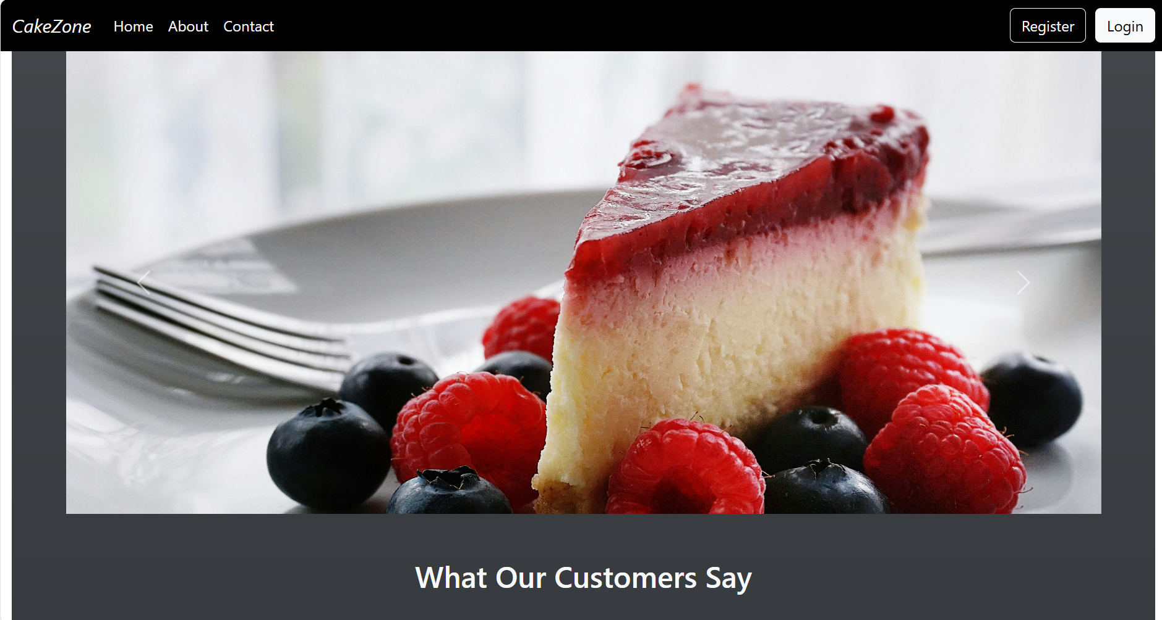

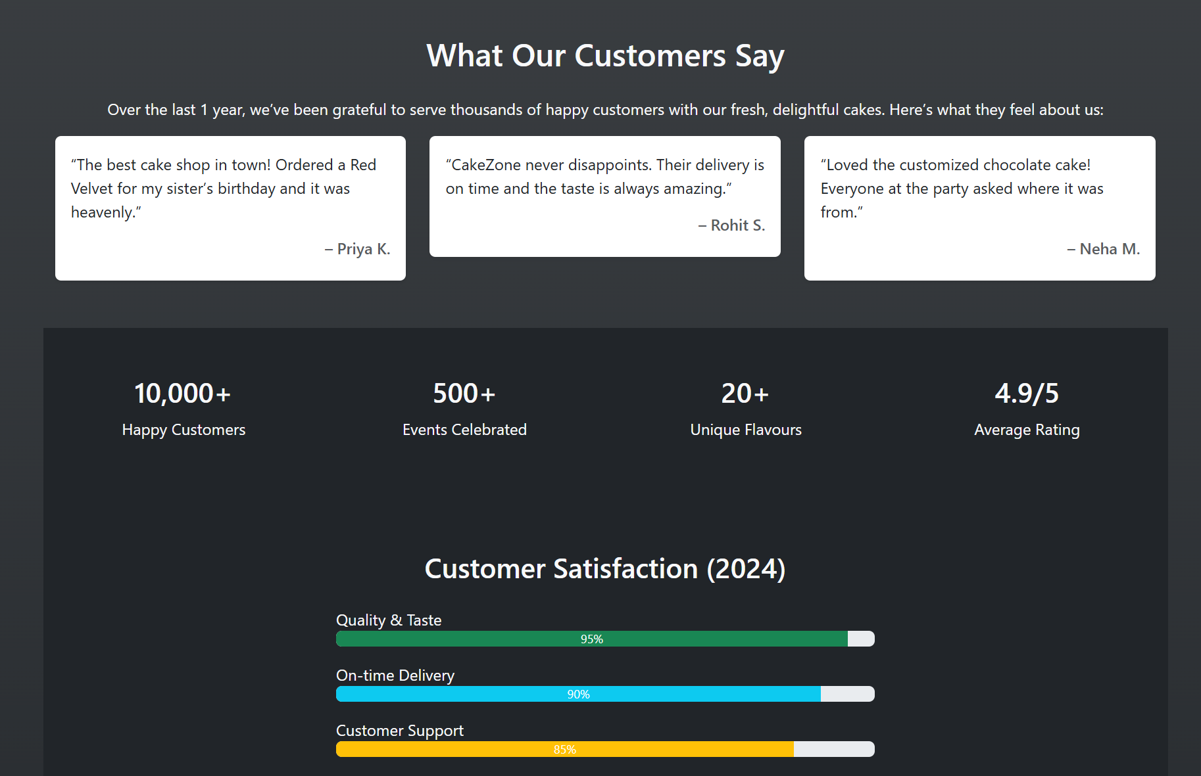

8.2 Register Page

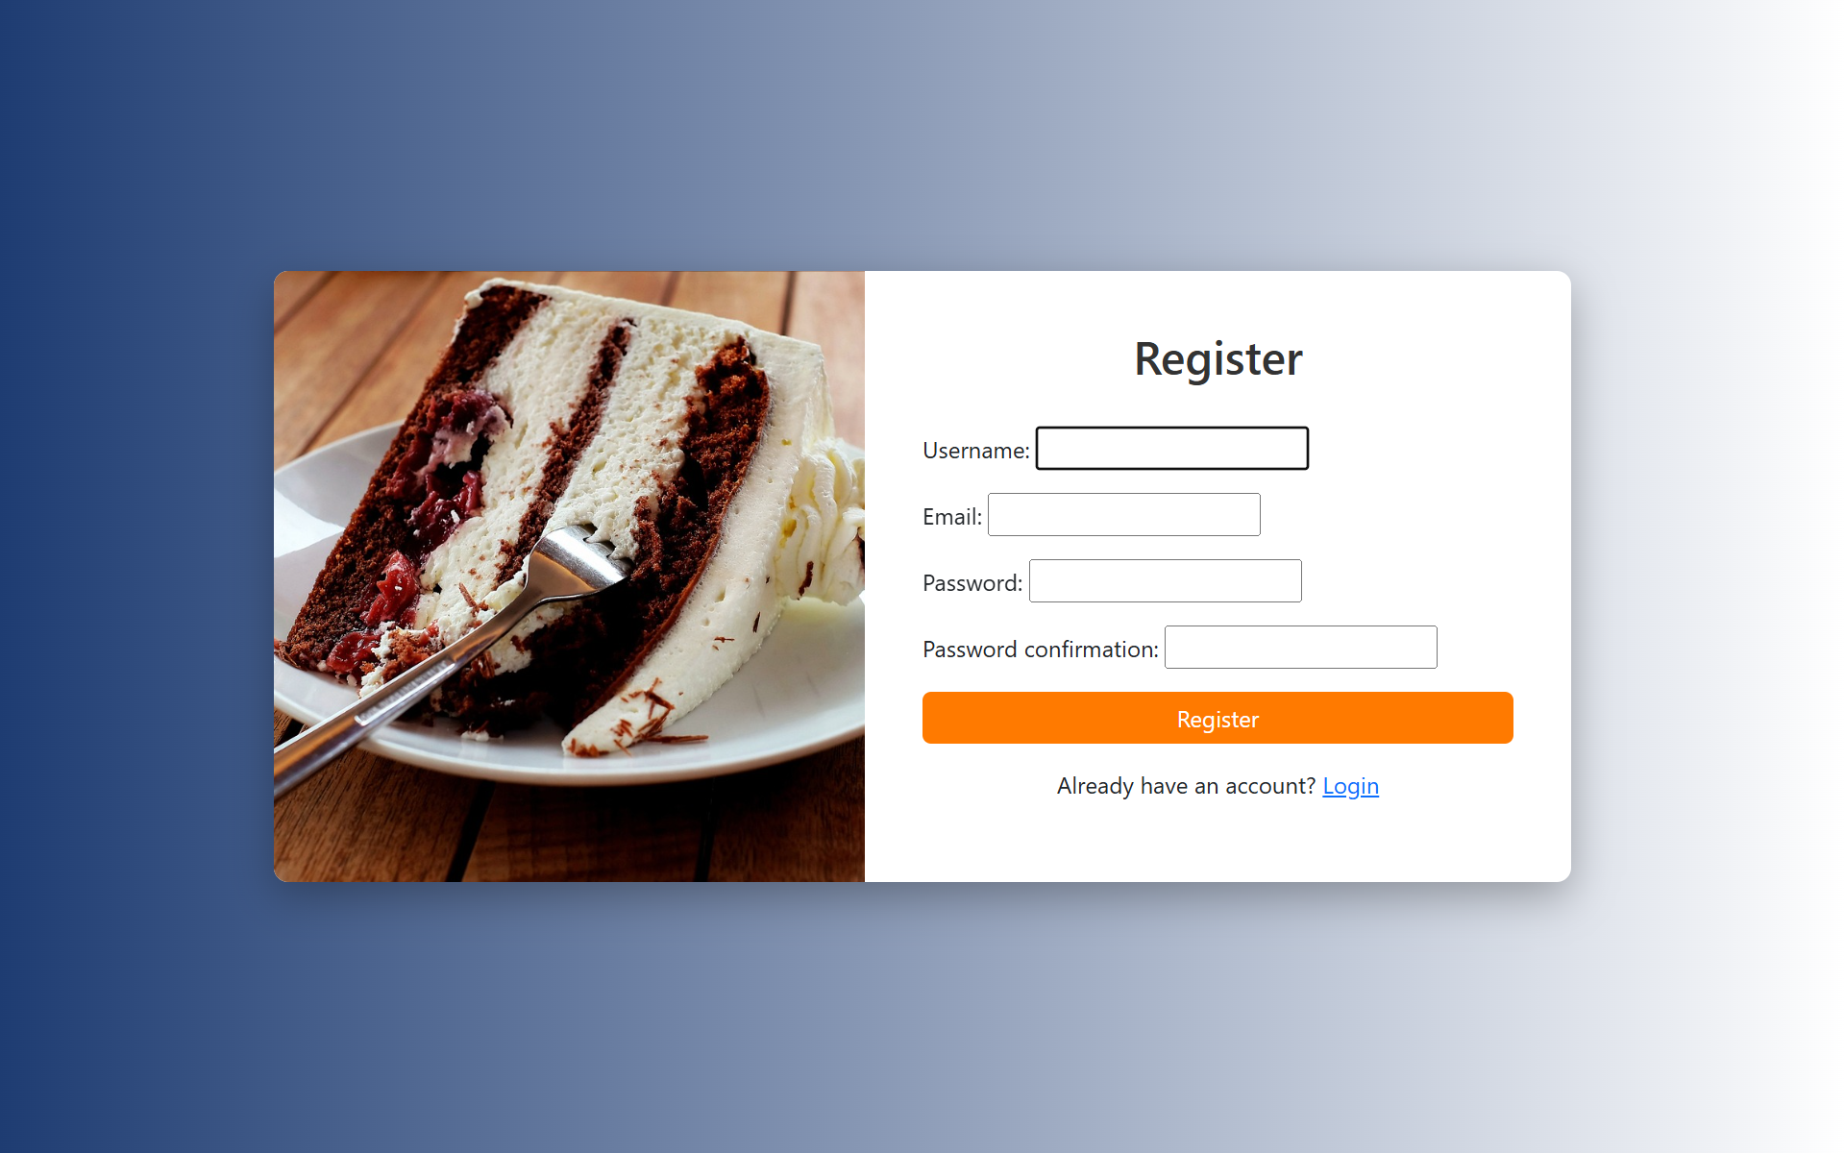

8.3 Login Page

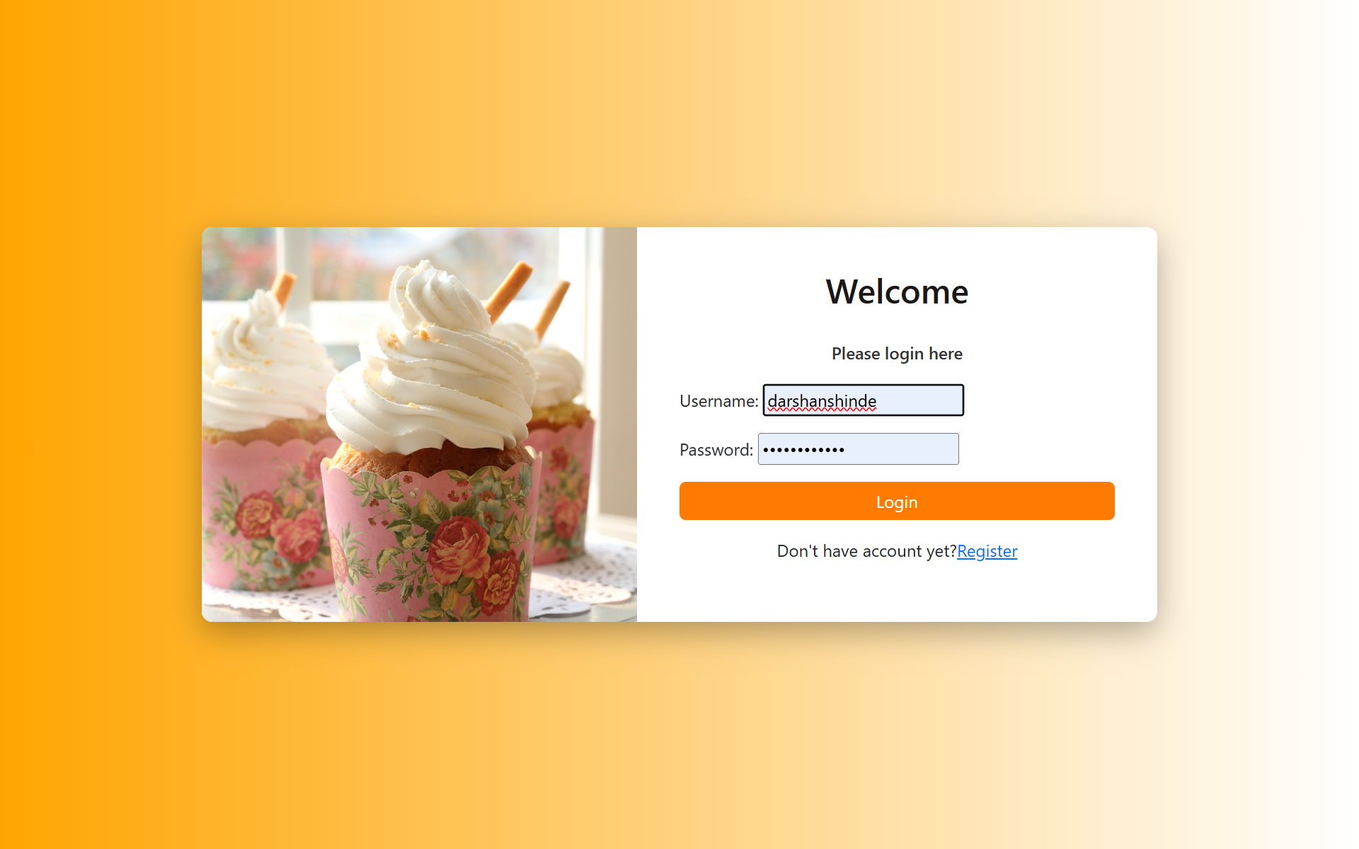

8.4 Home Page

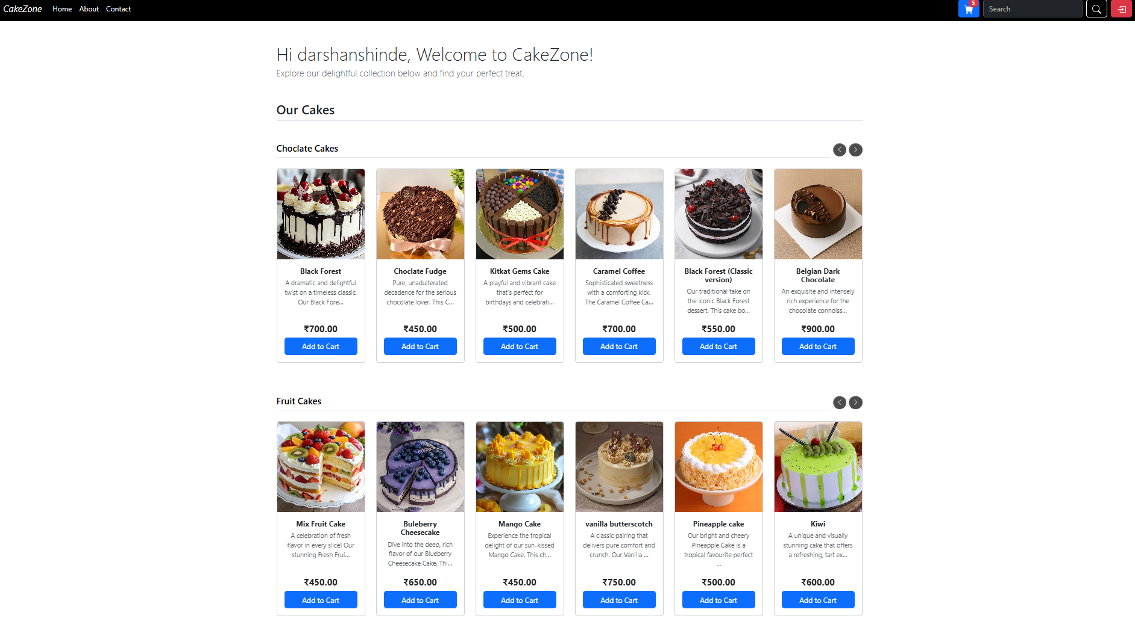

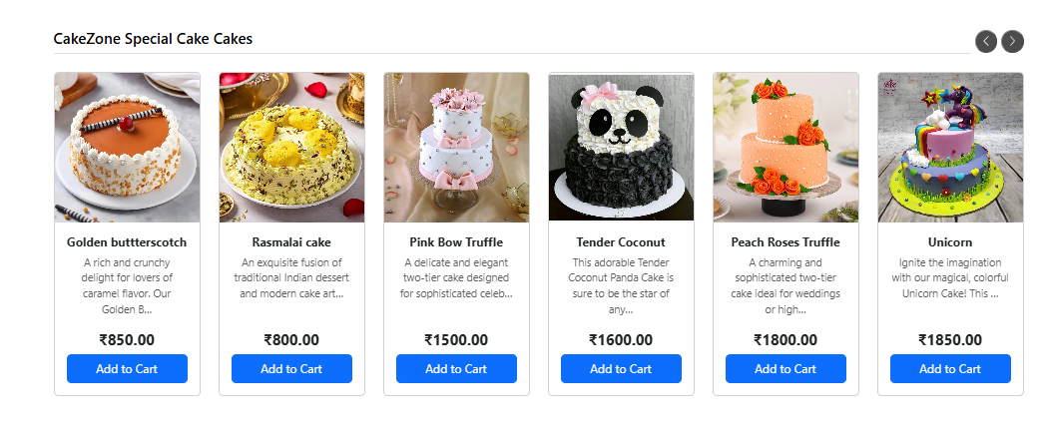

8.5 Cart Page

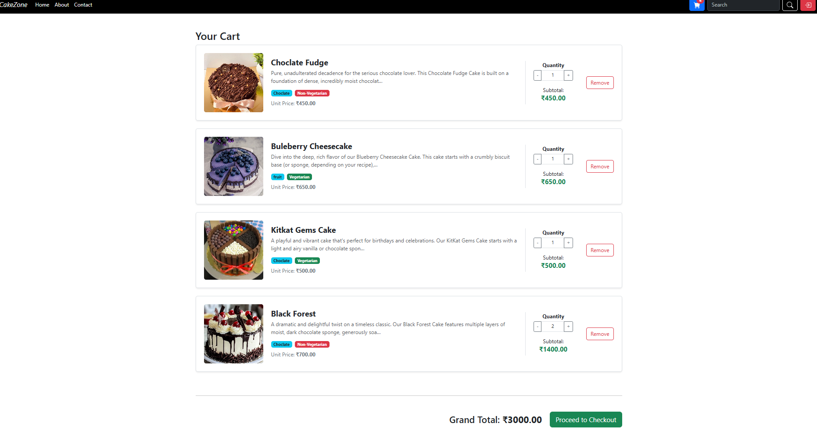

8.6 Checkout Page

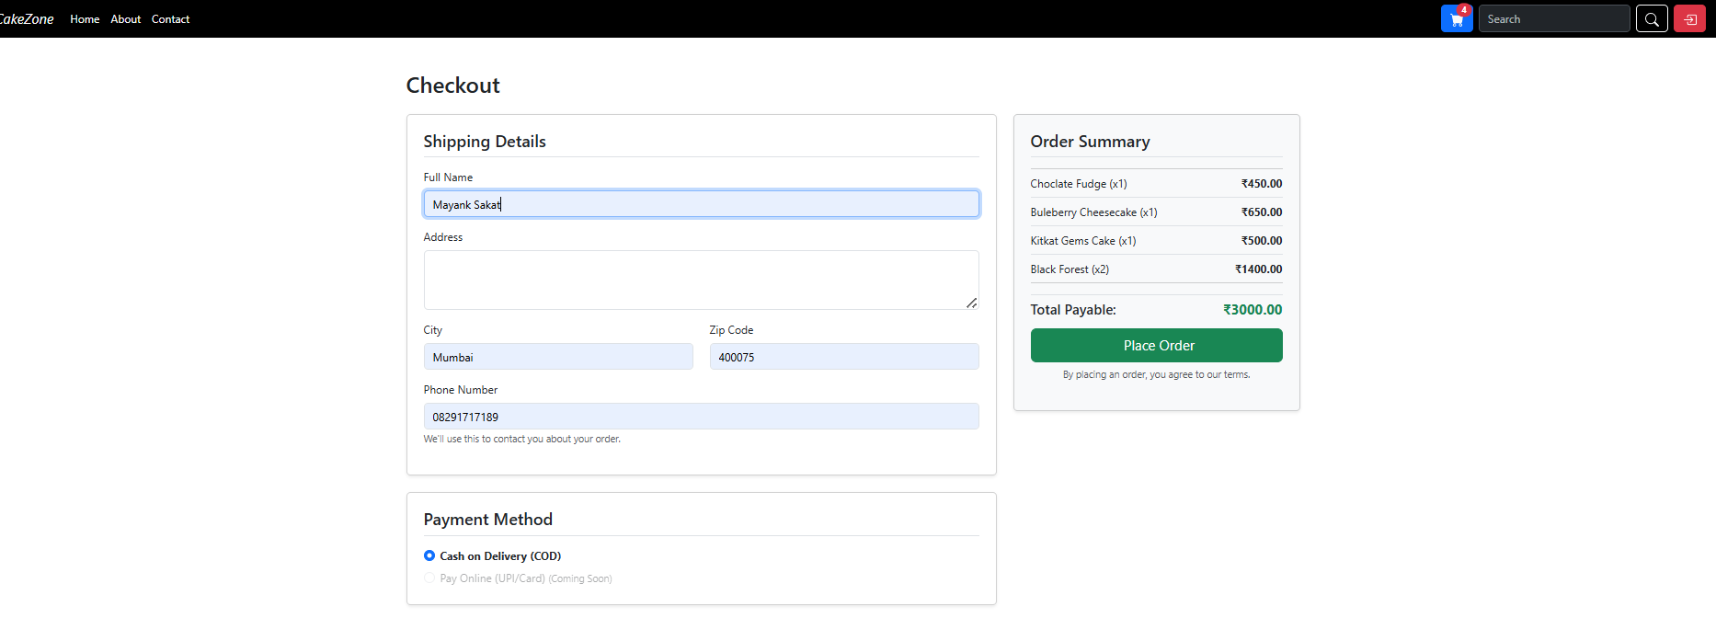

8.7 Order Summary Page

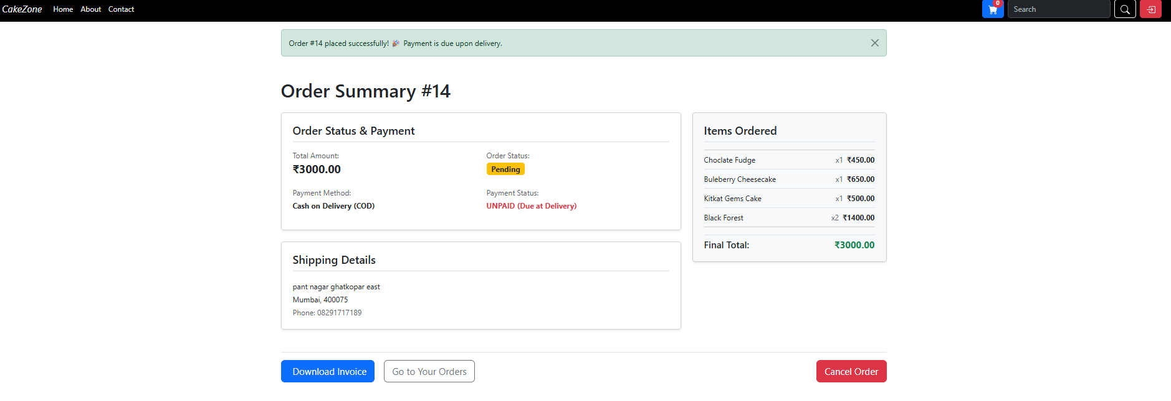

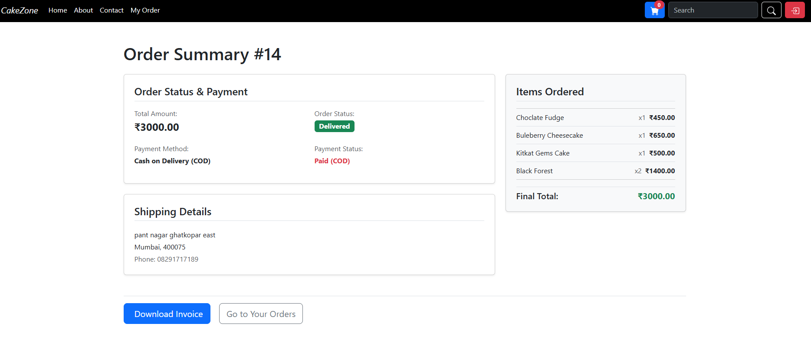

8.8 Order tracker Page

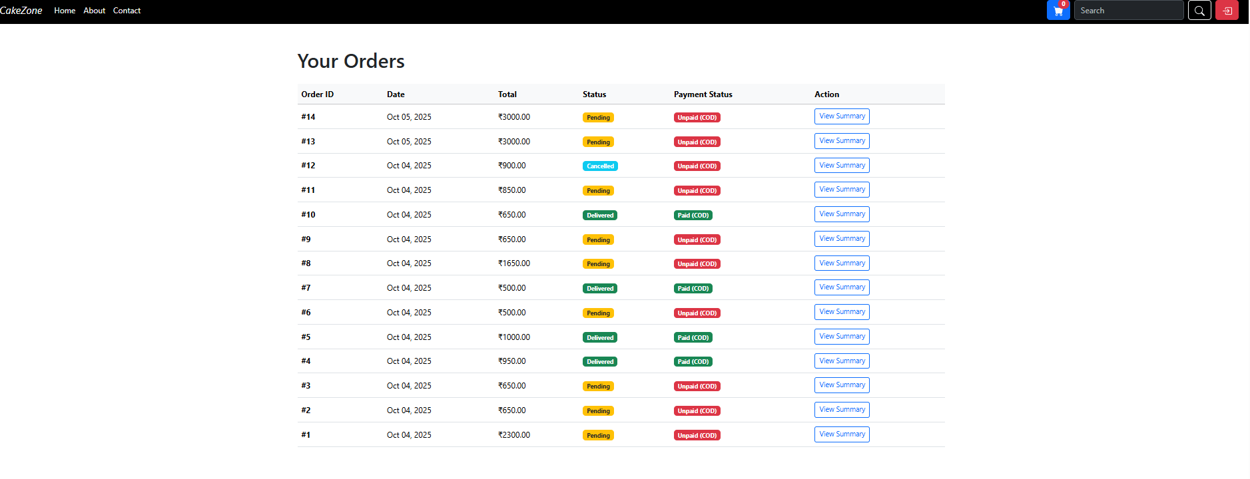

8.9 Contact Page

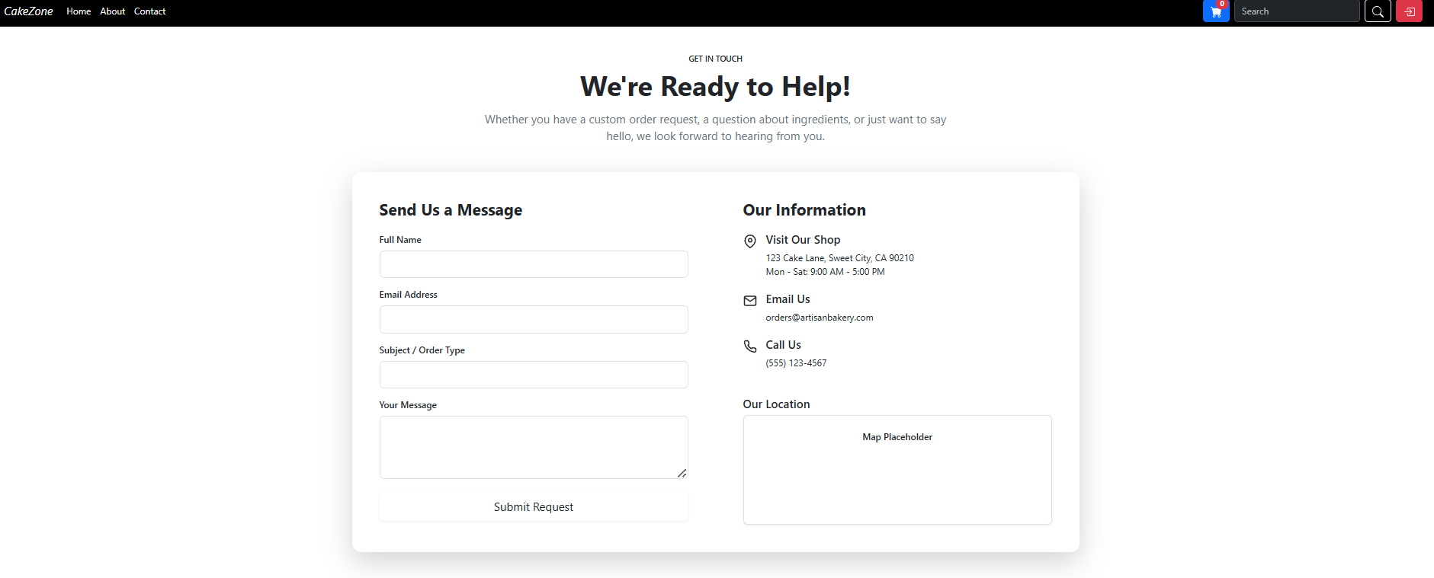

8.10 About Page

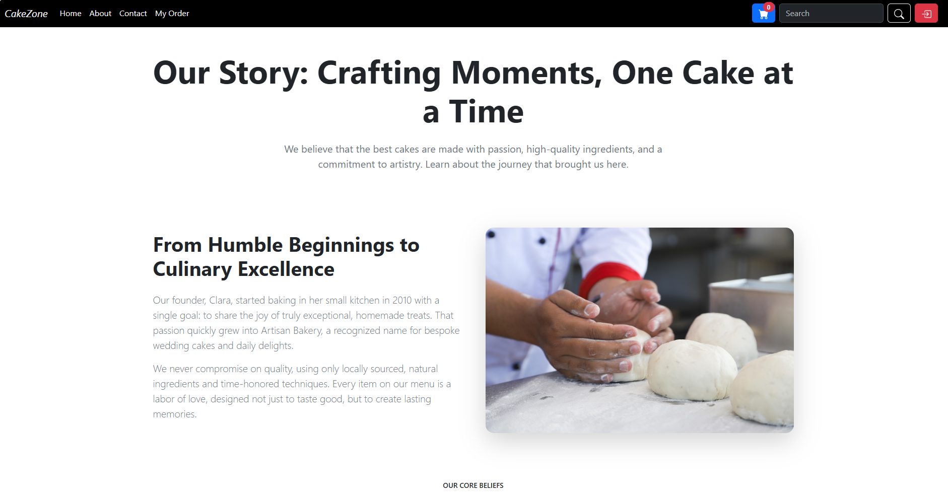

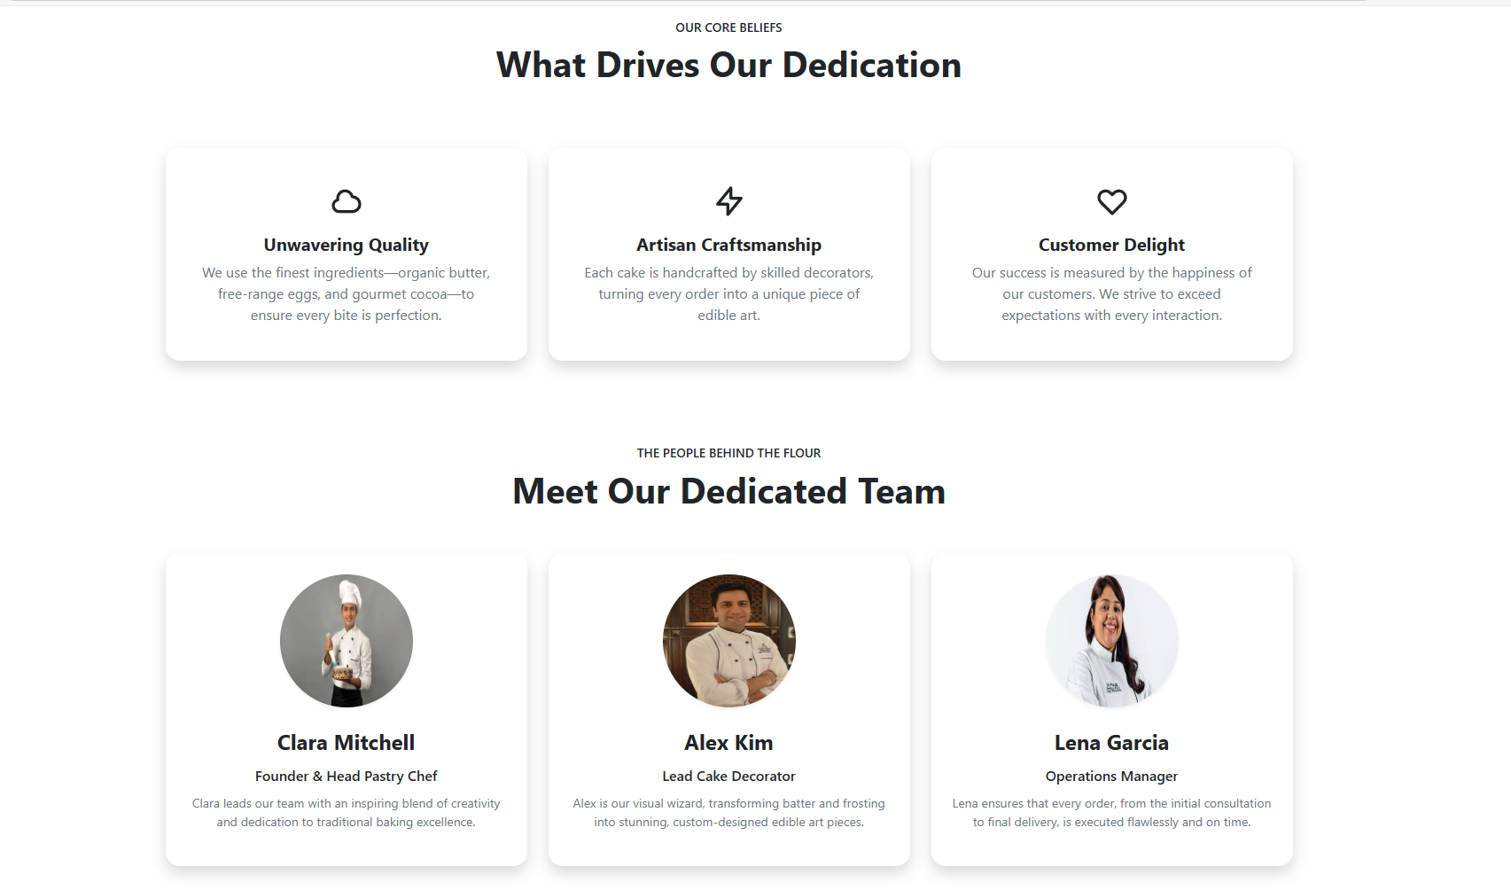

8.11 Invoice pdf

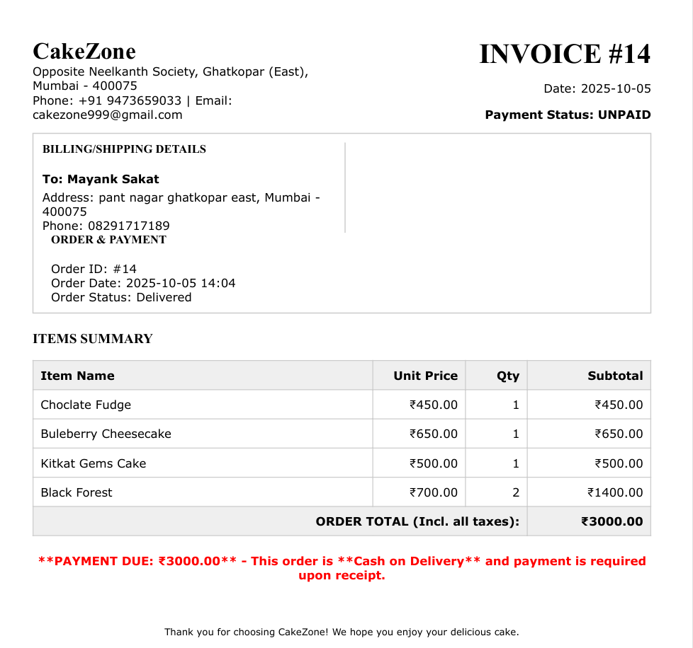

8.12 Admin Page

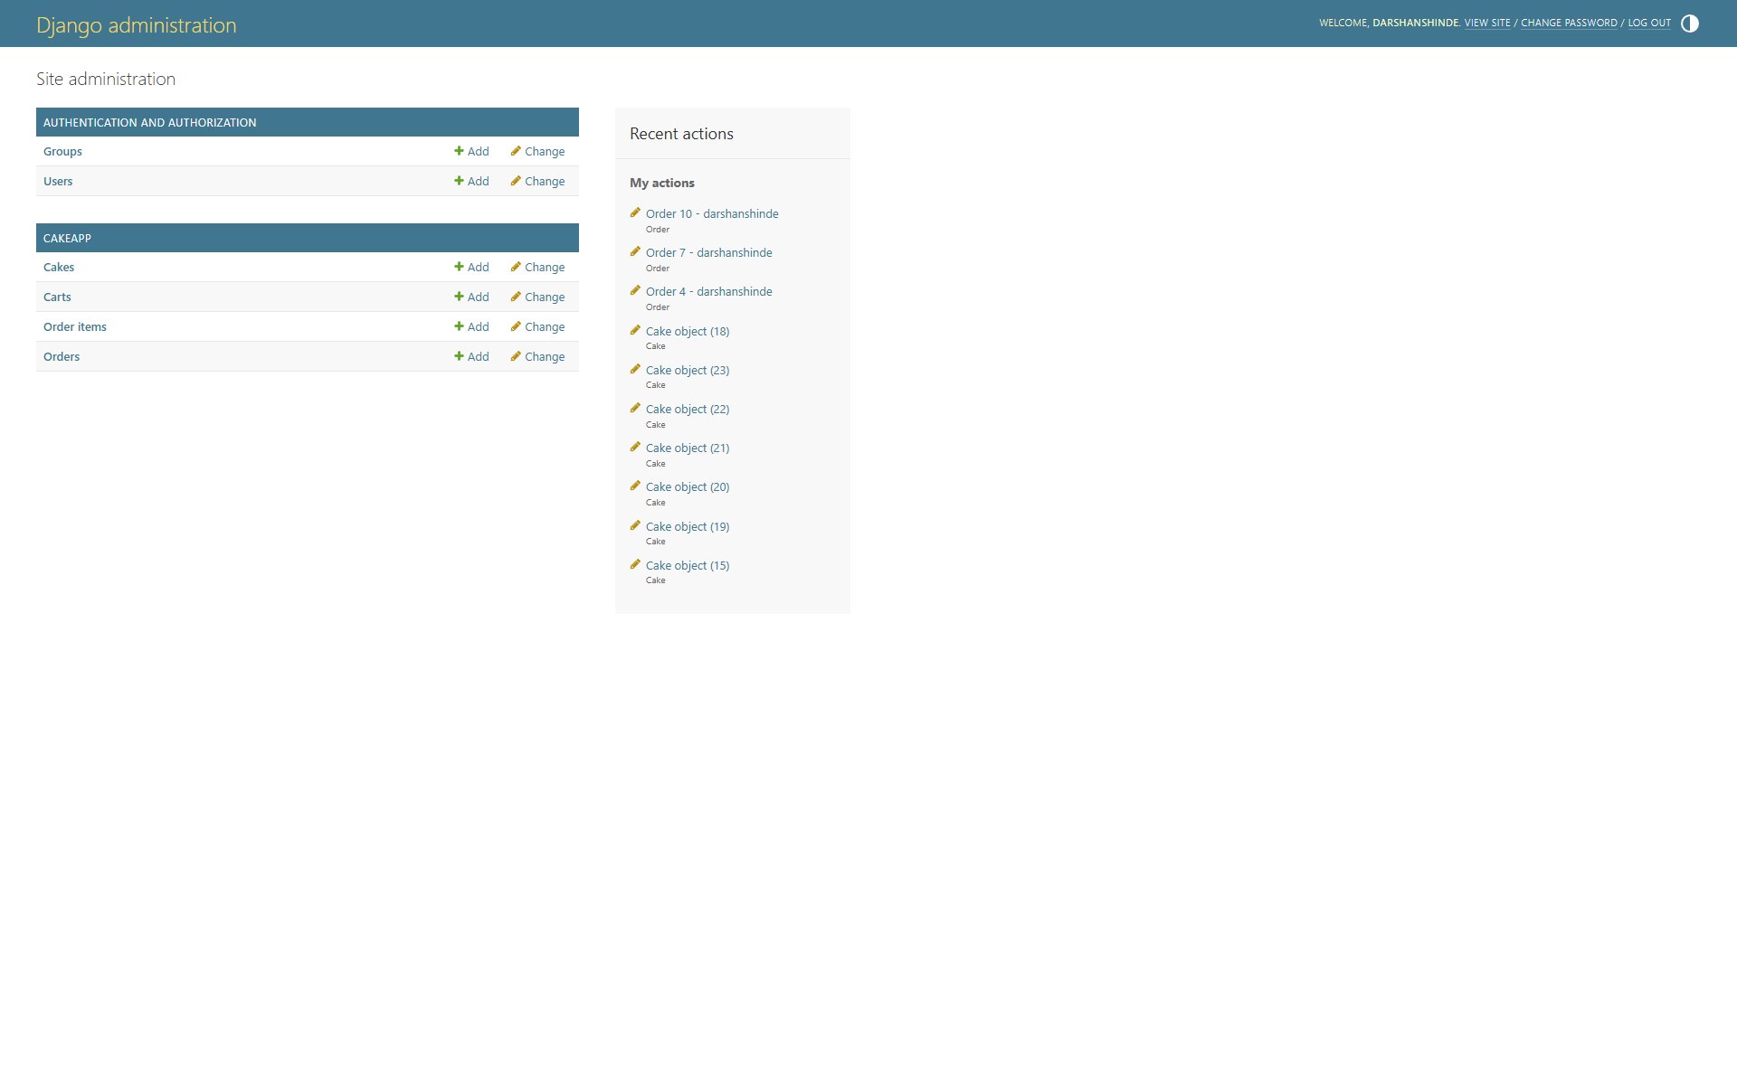

8.13 Add Cake (Admin)

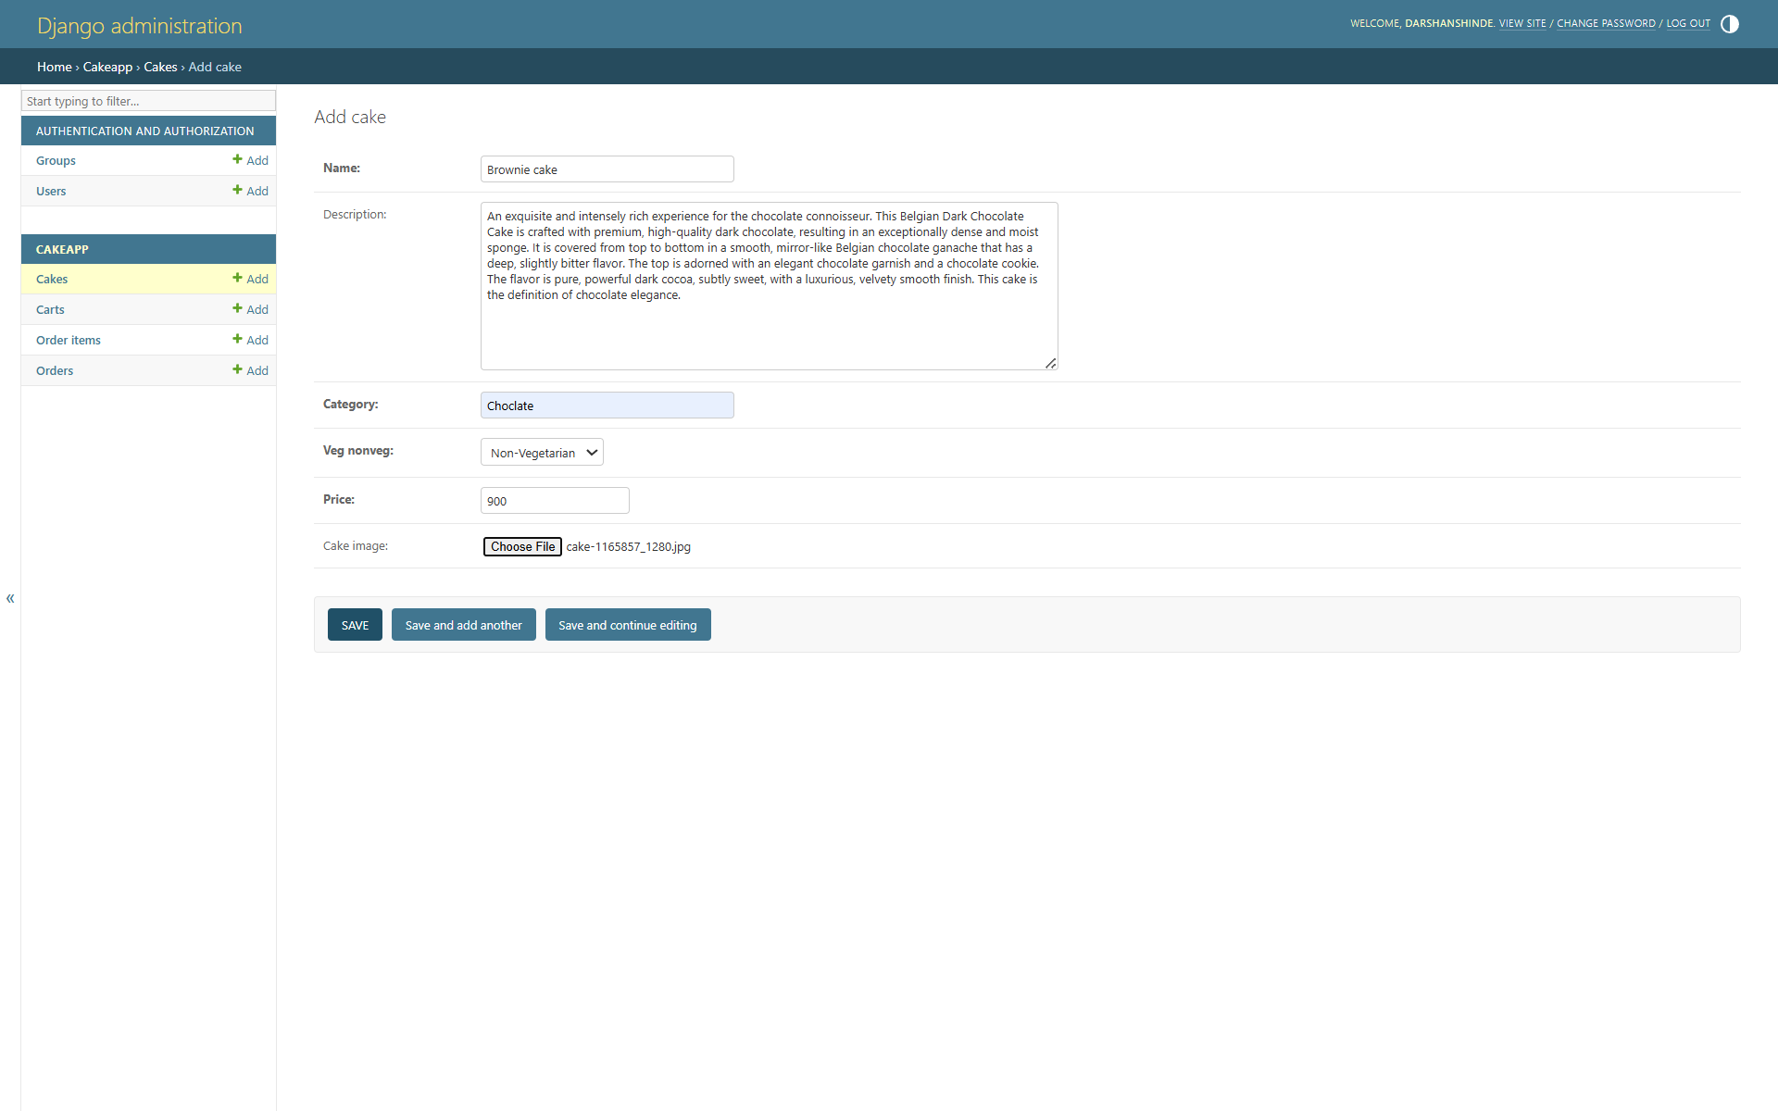

8.14 Order Manage Page (Admin)

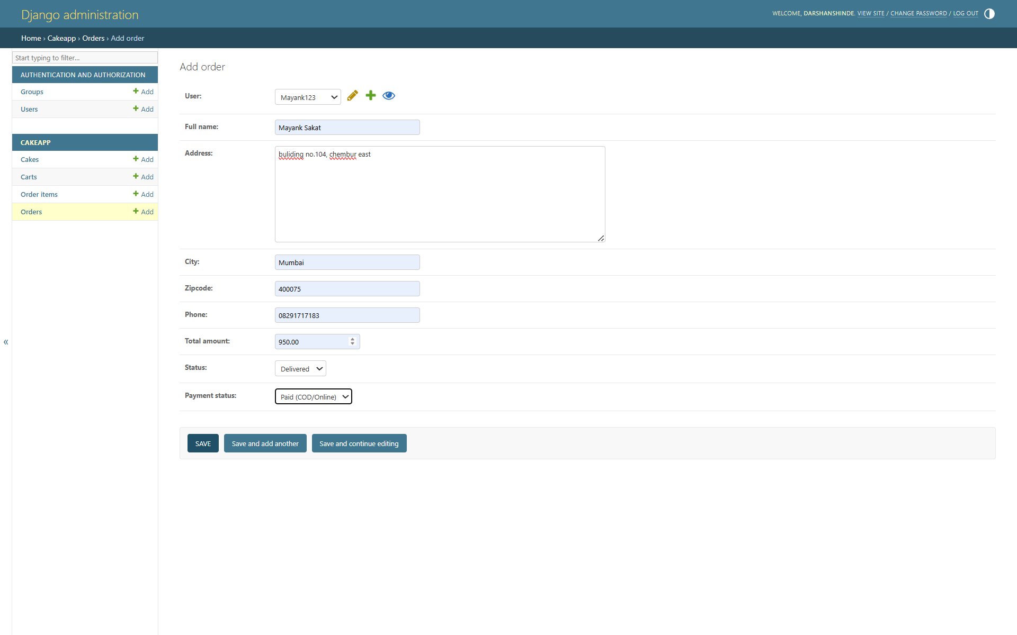

**9. CONCLUSION**

The Online Cake Shop Website demonstrates the power of digital platforms in simplifying and enhancing the cake ordering process. By providing a user-friendly interface, secure payment options, and efficient order management, the platform overcomes the limitations of traditional purchasing. This project not only offers greater convenience for customers but also helps business owners expand their reach and manage operations more effectively. Ultimately, the system provides a reliable, scalable, and efficient solution that bridges the gap between customers and bakery services, ensuring a smooth online shopping experience.

**10. BIBILOGRAPHY**

**Reference Books**

* + - * HTML and CSS Quick Start Guide.
      * UDEMY Django Course
      * Django Documentation
      * Python Quick Start Guide

**Reference Websites**

* + - * [http://github.com](http://github.com/)
      * [www.bootstrap.com](http://www.bootstrap.com)
      * [Gemini.google.com](https://gemini.google.com/)
      * ChatGPT ([https://chat.openai.com](https://chat.openai.com/))
      * CWH Youtube ([https://youtube.com](https://youtube.com/))

**12 PLAGARISIM REPORT**

